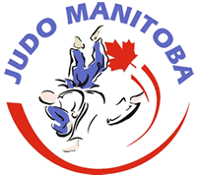

2022 Manitoba Open

October 14 – 16, 2022

Technical Package
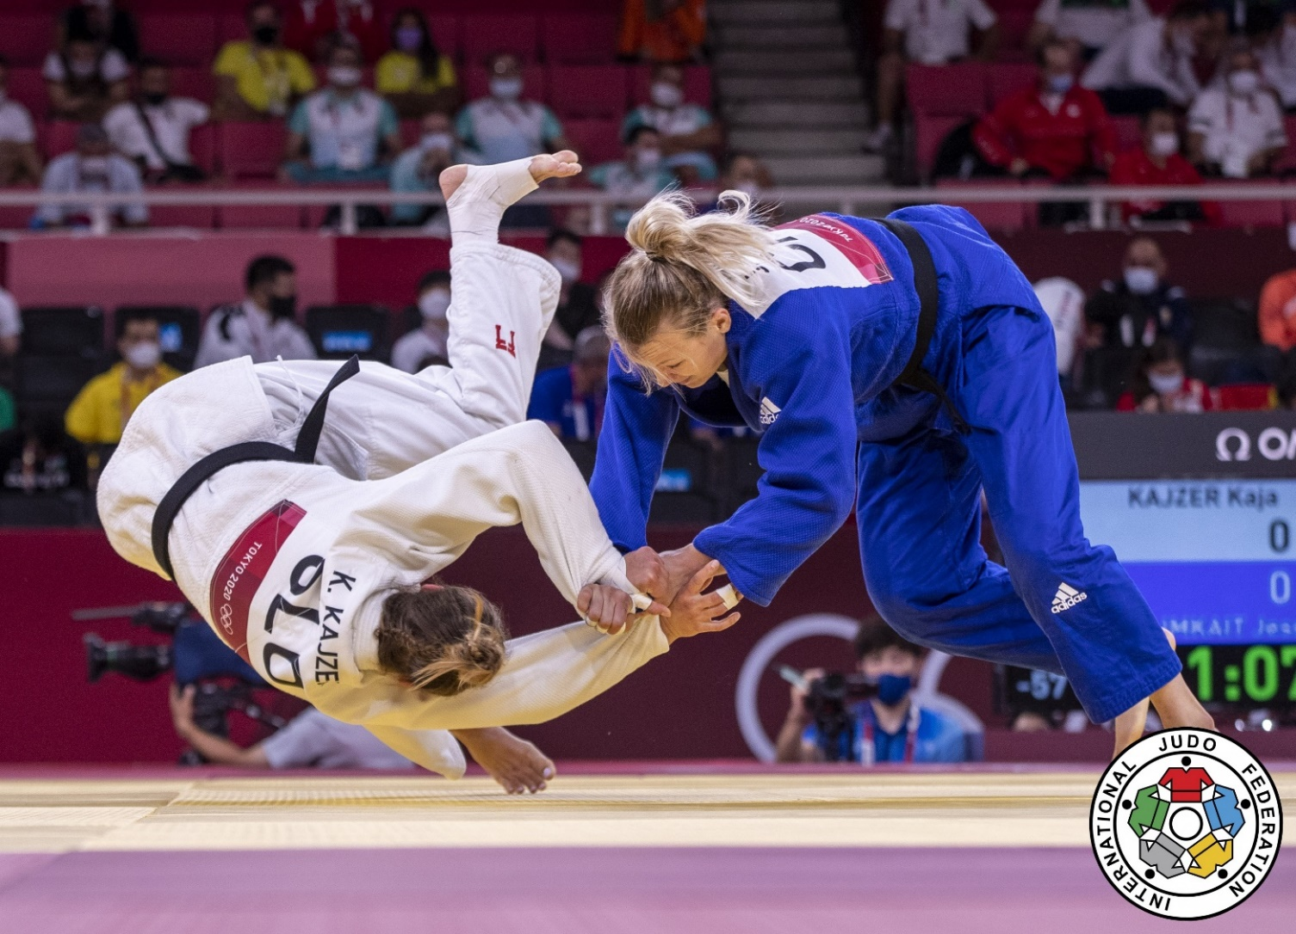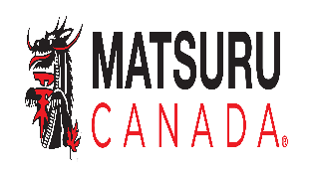
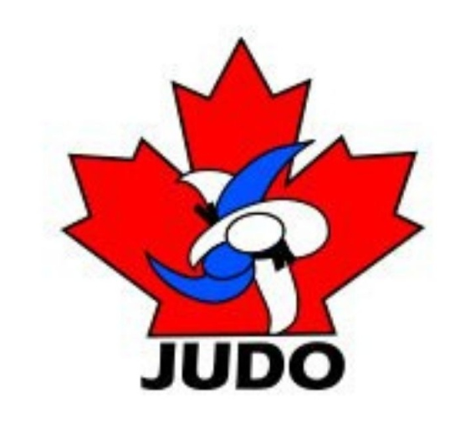

Dear Participants,
Judo Manitoba is pleased to invite you to compete at the first annual 2022 Manitoba Open in Winnipeg, Manitoba.
Winnipeg is brimming with culture, arts, sports, and entertainment. Located in the middle of the continent, you could call us the heart of North America -- as we pride ourselves on being Canada’s cultural center where live music, vibrant neighborhoods, enticing dining, shopping, fabulous festivals, and world-class attractions await to be explored.
Experience our diverse, cosmopolitan city that offers all the amenities you expect from a big city in an easy-going atmosphere. Whether you are applauding the frolicking polar bears swimming above you at Assiniboine Park Zoo’s Journey to Churchill experience, marveling at the awe-inspiring Canadian Museum for Human Rights or visiting Manitoba’s number one attraction, The Forks, Winnipeg has something for everyone.
Kindly refer to the event information and details that follow in this package and please assist with respecting the deadlines for registration and competition details.

Chers participants,
Judo Manitoba a le plaisir de vous inviter à participer au premier Open annuel du Manitoba en 2022 à Winnipeg, au Manitoba.
Winnipeg regorge de culture, d'arts, de sports et de divertissements. Situés au milieu du continent, vous pourriez nous appeler le cœur de l'Amérique du Nord, car nous sommes fiers d'être le centre culturel du Canada où de la musique live, des quartiers animés, des restaurants alléchants, des boutiques, des festivals fabuleux et des attractions de classe mondiale ne demandent qu’à être explorés.
Découvrez notre ville diversifiée et cosmopolite qui offre toutes les commodités que vous attendez d'une grande ville dans une atmosphère décontractée. Que vous applaudissiez les ours polaires qui s'ébattent au-dessus de vous lors de l'expérience « Journey to Churchill » du zoo du parc Assiniboine, que vous vous émerveillez devant l'impressionnant Musée canadien pour les droits de la personne ou que vous visitiez l'attraction numéro un du Manitoba, La Fourche, Winnipeg a quelque chose pour tout le monde.
Je vous remercie de vous référer aux informations et aux détails de l'événement qui suivent dans ce devis technique en respectant les délais d'inscription et les détails du tournoi.
Warm regards / Cordialement vôtre,
Milton Good
President Judo Manitoba

Key Contacts
- Tournament Director: Milton Good – mgood@shaw.ca
- IT Management: James Colp – james.colp@outlook.com
- Chief Official – Christian Royer- judoroyer@yahoo.com
- Kata Technical Director: Gerald Poirier- geraldpoirier2311@gmail.com
- Kata Chief Judge: Mohamad Hussani- mohdia@sympatico.ca
- Chief Referee: Miguel Rueda – Miguel.rueda@aircanada.ca
Sanctioned by Judo Canada Schedule*
*Please note the schedule is subject to change.
Friday, Oct 14, 2022
9:00 to 16:00 | Ju No Kata and Itsutsu no Kata Clinic | U of M Combative Room
18:00 to 21:00 | Weigh-ins for U14, U18, U21, Veterans and Newaza at the tournament site | Dakota Community Center
16:30 to 18:00 | Kata Judge meeting | Host Hotel
19:00 to 21:00 | Referee meeting | Host Hotel

Saturday, Oct 15, 2022
8:00 | No Changes to the Draw sheets after 8:00 AM  Kata Competition Starts | Dakota Community Center
7:30 | Kata Judge meeting | Dakota Community Center
8:00 | Referee Meeting | Dakota Community Center
10:00 | Competition Starts  U14 and Newaza | Dakota Community Center
12:00 | Competition Starts  U18, U21 and Veterans | Dakota Community Center
14:00 to 16:00 | U16 and Senior Weigh-in  Second Division check in for Sunday is required | Dakota Community Center

Sunday, Oct 16, 2022
8:00 | No Changes to the Draw sheets after 8:00 AM | Dakota Community Center
8:00 | Referee Meeting | Dakota Community Center
9:00 | Competition Starts  U16 and Senior | Dakota Community Center

Dates
- Accommodations must be booked prior to September 14, 2022, to guarantee rates
- Tournament registration deadline is October 7, 2022.

Organizing Committee
Judo Manitoba
311-145 Pacific Ave
Winnipeg MB
R3B 2Z6
Email: judo@sportmanitoba.ca

Tournament President
Milton Good

Tournament Director
Milton Good

Technical Director Kata
Gerald Poirier

IT management
James Colp

Responsible for registration, membership registration and draw
James Colp

Chief Official
Christian Royer

Chief Referee
Miguel Rueda

Chief Kata Judge
Mohamad Hussani

Medical
Pierre Plourde

Emergency/Questions
Milton Good
mgood@shaw.ca

Tournament Venue
Dakota Community Center
1188 Dakota St
Winnipeg MB
R2N 3H4

Accommodation
Official hotel of the tournament:
Canad Inns Destination Centres feature deluxe guestrooms with queen - or king - sized beds including Executive King suites with pull out couch.

Rates
Standard room 2 queen beds: $100.00
Executive King with pull out couch (Fort Gary location only): $118.00

Please select hotel links in below order to search for availability.

- Canad Inns Destination Centre Fort Garry – Host Hotel**
1824 Pembina Hwy
https://www.reseze.net/servlet/SendPage?hotelid=1681&skipfirstpage=true&page=186105

- Canad Inns Destination Centre Club Regent Casino Hotel
1415 Regent Ave
https://www.reseze.net/servlet/SendPage?hotelid=1680&skipfirstpage=true&page=186109

- Canad Inns Destination Centre Windsor Park
1034 Elizabeth Road
https://www.reseze.net/servlet/SendPage?hotelid=1688&skipfirstpage=true&page=186107

Transportation
- Taxis available outside airport arrival doors.
- Car rentals - Car Rentals | Winnipeg James Armstrong Richardson International Airport (waa.ca)
- Bus transportation provided between hotels and tournament site.

Registration
THIS IS A PRE-REGISTRATION ONLY TOURNAMENT:

- Athlete Registration:
  - Online registration for all athletes:
  - Trackie - https://www.trackie.com/online-registration/register/2022-manitoba-open/481460/
- Coach Registration: (Minimum NCCP 2 (DI) Trained)
  - Online registration is mandatory for all coaches:
  - Trackie- https://www.trackie.com/online-registration/register/2022-manitoba-open-coaches-referees/481461/
  - Only 4 coaches per team/dojo allowed.
- Referee and Kata Judges Registration:
  - Online registration is mandatory for all referees and kata judges:
  - Trackie - https://www.trackie.com/online-registration/register/2022-manitoba-open-coaches-referees/481461/

Provincial/Territorial Associations are responsible for selection and registration of their teams. The maximum quotas per province/age division/gender is 50. Distribution of athletes within this quota is decided by the province/territory.
All entries including request for the approval of an early bloomer’s entry and second entries must be received by the National Office in writing on the official entry forms no later than 2022 Friday October 7, along with the following:
- Registration forms (Excel only – do not complete by hand)
- Completed & signed release forms
- Medical history forms

NOTE: To athletes intending to compete in more than one age division based on the “Early Bloomer Clause” – the regulations as published in the 2022 edition of the “Tournament Standards and Sanctions” will apply.

Entries received after the specified above deadline are subject to an additional $30/entry. Late entries, second entries and changes to the original registration will be accepted until the end of the accreditation period for the event – 18:00 on Friday October 14th ,2022.

Eligibility
- Athletes must compete for the provincial association of which they are a member in good standing and have a valid Judo Canada membership card.
- The minimum belt rank for the Ne-waza events is a green belt.
- The registering entity (i.e. Country, Province, Territory, Club, Individual Coach) are/is responsible for ensuring that the athletes they register are eligible to compete. This includes the medical forms, waiver, and a confirmation of an early bloomer status where applicable.

Divisions
U14 – Born in 2010 and 2011
Female | -30kg; -33kg; -36kg; -40kg; -44kg; -48kg; -52kg; -57kg; -63kg; +63kg
Male | -32kg; -35kg; -38kg; -42kg; -46kg; -50kg; -55kg; -60kg; -66kg; +66kg
U16 – Born in 2008 and 2009
Female | -36kg; -40kg; -44kg; -48kg; -52kg; -57kg; -63kg; -70kg; +70kg
Male | -38kg; -42kg; -46kg; -50kg; -55kg; -60kg; -66kg; -73kg; +73kg
U18* – Cadet – Born in 2006, 2007 and 2008
Female | -40kg; -44kg; -48kg; -52kg; -57kg; -63kg; -70kg; +70kg
Male | -46kg; -50kg; -55kg; -60kg; -66kg; -73kg; -81kg; -90kg; +90kg
U21* – Junior – Born in 2003, 2004, 2005, 2006 ,2007 and 2008
Female | -48kg; -52kg; -57kg; -63kg; -70kg; -78kg; +78kg
Male | -60kg; -66kg; -73kg; -81kg; -90kg; -100kg; +100kg
Senior* – Born in 2008 and earlier
Female | -48kg; -52kg; -57kg; -63kg; -70kg; -78kg; +78kg
Male | -60kg; -66kg; -73kg; -81kg; -90kg; -100kg; +100kg
Veteran – Born in 1993 and earlier
Female | -48kg; -52kg; -57kg; -63kg; -70kg; -78kg; +78kg
Male | -60kg; -66kg; -73kg; -81kg; -90kg; -100kg; +100kg
Note:
- For U14: Green belt min
- For U16 and U18: Green belt min.
- For U21: Blue belt min.
- For Senior: Brown belt min. and minimum age of 15 years old
- For Veteran:
  - Born in 1993 and earlier:
  - Blue belt min.
KATA – U23 – Junior – Born in 2000, 2001, 2002, 2003, 2004 and 2005
Nage-No-Kata; Kodokan Goshin-Jutsu; Katame-No-Kata; Ju-No-Kata; Kime-No-Kata
Minimum rank: 3rd kyu (green)
KATA – Senior – Born in 1999 and earlier
Nage-No-Kata; Katame-No-Kata; Ju-No-Kata; Kime-No-Kata; Kodokan Goshin-Jutsu
Minimum rank: 1st kyu (brown)
NE-WAZA** – Born 2008 and earlier
Female | -57kg; -70kg; +70kg
Male | -66kg; -81kg; +81kg
Note:
- For Ne-waza: Green belt min.
*Younger participants are allowed to compete as per the Early Bloomer clause:
https://www.judocanada.org/tournament/.
** The organizers reserve the right to modify or combine weight divisions in case of an inadequate number of participants.
NOTE: No athlete is allowed to compete in three different age divisions in this tournament unless otherwise approved on a case-by-case basis by the High Performance Committee. However, the Ne-waza event is not included in this restriction.

Fees
Division | Cost
U14 | $50
U16/U18 | $60
U21/Seniors | $70
Veterans | $70
Kata | $25
Ne-Waza | $70
Additional Division | $40
Late Fee | $30
Weight Division change | $20
Kata Seminar | $40

Competition Format
- U14
  - The modified double elimination format will be used.
  - In weight categories with five (5) or fewer competitors, the round-robin format will be used.
  - Tournament regulations as per Judo Canada’s Sanction Policy and Tournament Standards – 2022-2023.
- U16
  - The modified double elimination format will be used.
  - In weight categories with five (5) or fewer competitors, the round-robin format will be used.
  - Tournament regulations as per Judo Canada’s Sanction Policy and Tournament Standards – 2022-2023.
- U18:
  - The modified double elimination format will be used.
  - In weight categories with five (5) or fewer competitors, the round-robin format will be used.
  - Tournament regulations as per Judo Canada’s Sanction Policy and Tournament Standards – 2022-2023.
- U21:
  - The modified double elimination format will be used.
  - In weight categories with five (5) or fewer competitors, the round-robin format will be used.
  - Tournament regulations as per Judo Canada’s Sanction Policy and Tournament Standards – 2022-2023.
- Seniors:
  - The modified double elimination format will be used.
  - In weight categories with five (5) or fewer competitors, the round-robin format will be used.
  - An athlete must have at least two (2) victories to obtain points and standard from Judo Canada.
  - Tournament regulations as per Judo Canada’s Sanction Policy and Tournament Standards – 2022-2023.
All issues/cases(s) that are unexpected or deemed exceptional circumstances will be solved by decisions taken by the Judo Canada designated Chief Official in cooperation with the Organizing Committee.

Medal Ceremony
Medal winners must attend the medal ceremony in their WHITE judogi. Medal winners who refuse to participate in the ceremony will be removed from the result list and will not place (carding points may be removed).
No promotion articles are authorized to be used/displayed on the podium (flags, T-shirt, socks or similar items).

Damages
No use of bleeding dyes on the body or hair of competitors is allowed. In cases such use is undetected and damage results to the equipment of the opponent or tatami, the competitor will be disqualified and the Provincial or Territorial Association of which that individual is a member will be charged for the damage.

Insurance
Judo Canada and Judo Manitoba (or any of its officials or members) will not be liable or responsible for any personal injury nor for any loss or damage to any property resulting from participation and travelling in connection with these championships.

More information
NOTE: The Tournament Director and Judo Canada reserve the right to revoke the accreditation of anyone showing blatant disrespect for the rules and procedures of the competition.

The modified double elimination system will be used during this event.

- Tournament Regulations as per Judo Canada’s Tournament Standards and Sanctions manual, unless specified otherwise in this document.
- A minimum of 2 competitors must be registered in a weight category for the competition to take place.
- Medals are only awarded if an athlete has won a match and according to Judo Canada Tournament Standards and Sanction protocol, i.e. two participants – only gold medal awarded; three participants – only gold and silver awarded; etc.
- This tournament will hold Kata competitions for KATAME-NO-KATA, JU-NO-KATA, KIME-NO-KATA NAGE-NO-KATA and KODOKAN GOSHIN JUTSU. There are no gender specific divisions, so all pairs are welcome (mixed or not). Multiple entries are accepted. The same competitor can enter only once in the same kata.
- FOR SHIAI: Both the blue and white judogis are mandatory. Reversible judogis will be accepted.
- FOR KATA: White judogis only. No red & white belts.
- Each team (including officials) is responsible for reserving its own accommodation according to format specified in this package.
- Accreditation will be done at time of weigh-ins.
- No use of bleeding dyes on the body or hair of competitors is allowed. In cases such use is undetected and results in damage to the equipment of the opponent or the tatami, the competitor will be disqualified and the Provincial Association of which that individual is a member will be charged for the damage.

For any concerns or questions, please contact Milton Good: mgood@shaw.ca

