OTTAWA TWILIGHT #7
DATE: Wednesday July 6th, 2022
LOCATION: Terry Fox Athletic Facility, 2960 Riverside Dr. Ottawa, ON K1V 8N4
SANCTIONED BY: Athletics Ontario.
AGE CATEGORIES: OPEN
ENTRY DEADLINE: Tuesday, June 5th at Noon HERE
FEES: Online - $25.00
IMPLEMENTS: Athletes are asked to bring their own. A limited number of implements may be available but requests must be made with plen ty of time. Ottawa Lion members receive priority.
CHECK IN: Athletes are asked to marshal at the start line of their event no later than 10min prior to the start. Distance runners will be required to pick up a hip/chest number at the Ottawa Lions tent located under the timing tower.
PARKING: Limited parking will be available at the venue. Pay and display parking in the
Mooneys Bay lot will also be available. With the Mooneys Bay park attractions the lots will fill up quickly.
LIVE RESULTS: liveresults.ottawalions.com
SCHEDULE OF EVENTS: Will be run men before women (unless indicated otherwise). Seeded/fast sections will be run first. Events may be combined if entries are low.

TRACK EVENTS:
5:45pm Youth 60m mini Hurdles & 60m Dash
Men 400m
Women 400m
80m Hurdles
100m Hurdles
110m Hurdles
Men 1000m
Women 1000m
Men 200m Heats
Women 200m Heats
1500m Invite
Men 2000m
Women 2000m
Men 200m Final
Women 200m Final
4x100m Relay

FIELD EVENTS:
6:00pm Combined High Jump
Men Triple Jump
Combined Discus Throw
7:00pm Women Long Jump
Combined Javelin Throw
FACILITY LAYOUT
WARM-UP AREA
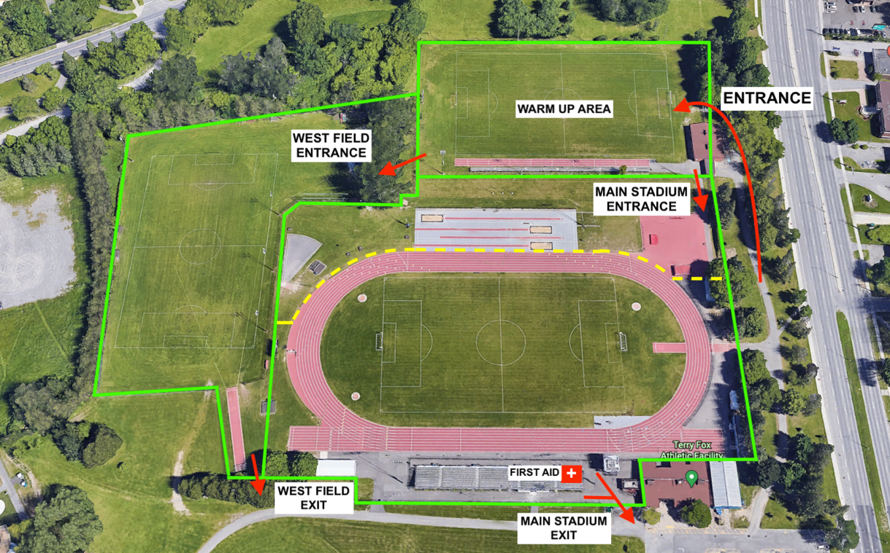

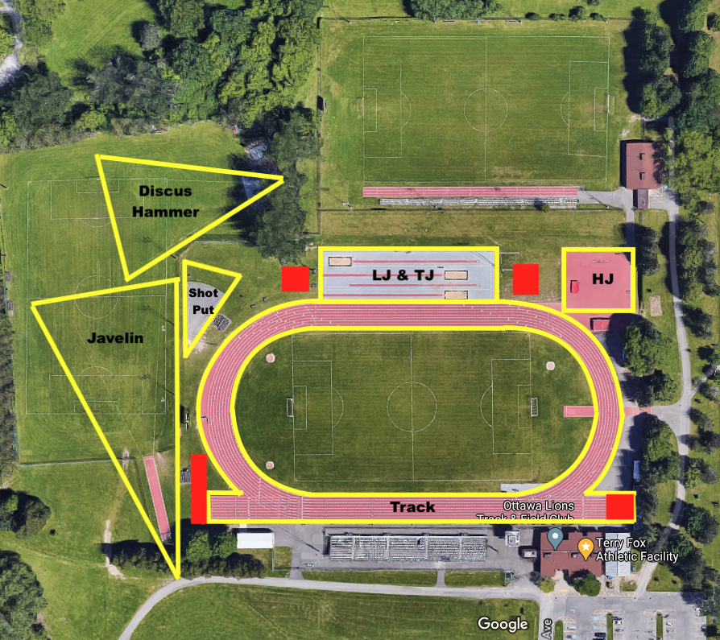
COMPETITION AREAS

EMERGENCY ACTION PLAN:
There will be a First Aid Team located on site for the duration of the weekend. The First-Aid station will be located just east of the grand stands. This team is not responsible for RMT or PT but a first response in case of injury or need to call EMS.

A defibrillator is located in the main building of the Terry Fox Athletic Facility.

If EMS is required at the Terry Fox Athletic Facility, the address is 2960 Riverside Dr. Ottawa Ontario K1V 8N4 (Inside Mooneys Bay Park). The best point of access is from the intersection of Riverside Dr. and Ridgewood Avenue, they should take an immediate right once inside Mooneys Bay Park. An alternative point of entry would be arriving from Hogs Back Rd, turning into the Mooneys Bay Boat launch entrance and pulling up to the West Field.

Under a severe weather warning or arrival of a thunder/lightning storm there are very few locations for shelter. While there are a few change rooms and locations for shelter, they will be limited in space as a 2m physical distancing rule will apply while indoors (along with wearing masks). We ask that athletes, officials and volunteers who drive to the venue take shelter in their respective vehicles until the storm subsides. Please do not welcome others you did not travel with into your vehicle

