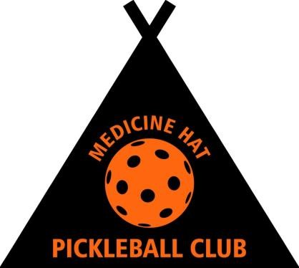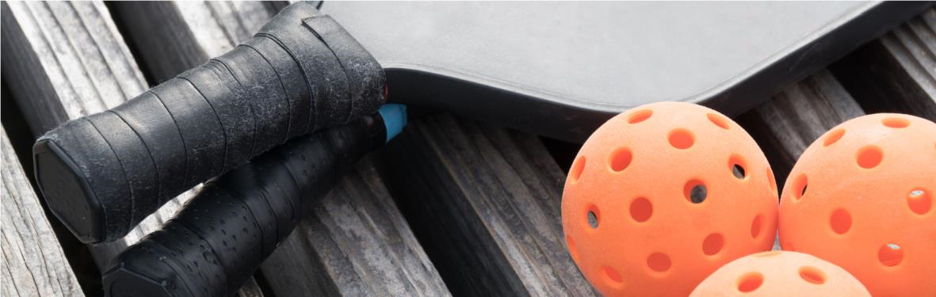
Thank you for your interest in becoming a MEMBER of the
Medicine Hat Pickleball Club (MHPC)

Our membership year runs from January 1 to December 31
Currently our ANNUAL Membership fee is:
$80 for an ADULT member (age 18 - 100) plus processing fees
$40 for a JUNIOR member (age 6 – 17) plus processing fees
This price includes memberships with Pickleball Canada (PC) & Pickleball Alberta (PA)

Our primary season is OUTDOORS on an amazing 20 court dedicated facility located on the SOUTH/EAST corner of the BIG MARBLE GO Centre. Weather permitting our season typically runs from April 1 to mid October. If available, we offer INDOOR Winter play opportunities.
Membership with the MHPC includes but is not limited to the following benefits:
Unlimited Outdoor Court Play Preferred or Member Pricing
Learn to Play Lessons Social and Competitive Play Opportunities
Skills and Drills (beginner & advanced) Insurance via PC Membership
Club Tournaments & Clinics Club Socials & Fellowship
Lighted Courts Off Season Play Opportunities
Fitness & Health & Wellness Benefits Access to Club Equipment
Youth Program & Lessons Scheduled & Drop-in Play Opportunities

Need more information? Please send an email to: mhpcmembershipmanager@gmail.com
Include your name and telephone number so that our club ambassador can contact you to address any further questions or concerns.
Ready to JOIN? Click this link where joining is just a click away: mhsspc.wixsite.com

The Medicine Hat Pickleball Club – “It’s FUNtastic!

