Date: Friday and Saturday January 14-15th, 2022
Location: University of Toronto Field House
Faculty of Kinesiology & Physical Education
55 Harbord Street Toronto, ON M5S 2W6

Start Time: Friday at 6:00PM and Saturday Track 10:00 am
*Meet may run up to 30 minutes ahead of schedule

Sanctioned by: Ontario University Association (OUA)
Hosted By: Faculty of Kinesiology & Physical Education
University of Toronto Track and Field Club

Meet Director: Bob Westman – bob.westman@utoronto.ca, Tel/text: 416-399-3466

Eligibility: OUA and USports Athletes Only

Entries: Must be submitted on-line by Wednesday Jan 12th, 2020 (12 noon)

Cheques: Cheque Payable to: University of Toronto

Facility: 200m flat Mondo - rubber 5-lane track with 8 sprint lanes. All runways Mondo - rubber; shot put circle concrete.

Spikes: MAXIMUM 6mm.

Timing: Fully electric timing.

Changing facility: Locker rooms are available for men and women. Please bring your own locks and towels.

Entry Fee: $20.00 per athlete per event

Cost limit $500 per team

Late Entry: Late entries will be accepted at $40.00 per athletes per events.

Late entries will only be accepted up noon on Thursday

SCRATCHES: Please make all scratches online or upon arrival to the Field House registration desk (top of the stairs).

Draft - Meet Schedule
 |  | Friday January 14th, 2022
6:00 PM | Weight Throw |  |  | Women
6:30 PM | Weight Throw |  |  | Men
7:00 PM | Shot Put |  |  | Women
7:30 PM | Shot Put |  |  | Men

Draft - Meet Schedule
 |  | Track - Saturday January 15th, 2022
10:00 AM | 60M hurdles heats |  |  | Women
10:15 AM | 60M hurdles heats |  |  | Men
10:30 AM | 4 x 200M timed sections |  |  | Women
10:40 AM | 4 x 200M timed sections |  |  | Men
10:55 AM | 1000M timed sections |  |  | Women
11:10 AM | 1000M timed sections |  |  | Men
11:30 AM | 60 hurdles finals |  |  | Men
11:40 AM | 60 hurdles finals |  |  | Women
 | Track Break
12:50 PM | 60M heats |  |  | Men
1:10 PM | 60M heats |  |  | Women
1:40 PM | 600M timed sections |  |  | Women
1:50 PM | 600M timed sections |  |  | Men
2:05 PM | 1500M timed sections |  |  | Women
2:20 PM | 1500M timed sections |  |  | Men
2:40 PM | 60M finals |  |  | Women
2:45 PM | 60M finals |  |  | Men
2:55 PM | 3000M timed sections |  |  | Women
3:15 PM | 3000M timed sections |  |  | Men
3:40 PM  35 | 300M timed sections |  |  | Women
4:10 PM | 300M timed sections |  |  | Men
4:45 PM | 4 x 800m timed sections |  |  | Women
5:00 PM | 4 x 800m timed sections |  |  | Men
5:10 PM | 4 x 400m timed sections |  |  | Women
5:15 PM | 4 x 400m timed sections |  |  | Men

Final - Meet Schedule
 |  | Field SATURDAY January 15th, 2022
10:00 AM | Long Jump |  |  | Women
10:00 AM | High Jump |  |  | Women
11:00 AM | Pole Vault |  |  | Men
12:00 PM | Long Jump |  |  | Men
1:00PM | High Jump |  |  | Men
1:30 PM | Triple Jump |  |  | Men
1:30 PM | Pole Vault |  |  | Women
3:00 PM | Triple Jump |  |  | Women

NEW For the University of Toronto Athletic Centre Field House
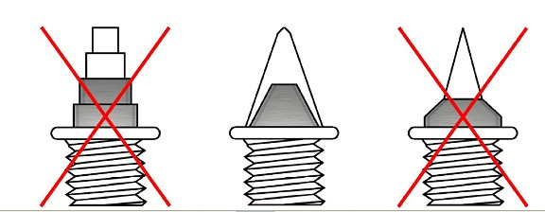

SPIKES
• All spikes must be presented to be checked at the spike check in table (where you receive your hip numbers)
• Athletes will not be allowed to compete without having their spikes checked and cleared .
• Acceptable spikes: 6mm pyramids / cones – same size
• Any athletes competing with longer than 7mm spikes will be disqualified.
• Water is the only permitted drink allowed on the track facility.

How to get the University of Toronto Athletic Centre: - 55 Harbord St.Toronto, Ontario, Canada, M5S 2W6

The Athletic Centre is located on the west side of U of T’s St. George campus at the intersection of Harbord St. and
Spadina Ave. It is easily accessible from the Spadina subway station and by streetcar.

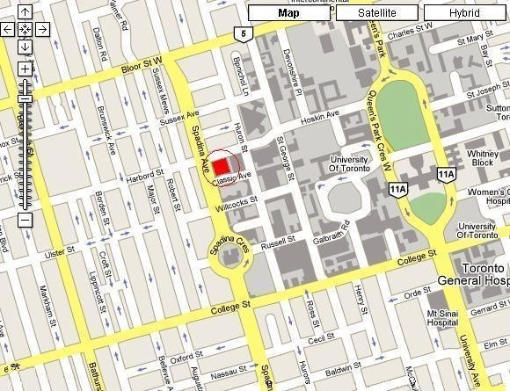

From the Gardiner Expressway:
Gardiner Expressway to Spadina Ave. Turn left (go north) on Spadina Ave. Turn Right onto Harbord St and enter through first set of doors.

From 401 (East of DVP): 401 West to Don Valley Pkwy. Don Valley Pkwy South to Bloor St. West on Bloor St. to
Spadina Ave.. Turn Left onto Spadina Ave. Turn Left on Harbord St and enter through first set of doors.

From 401 (West of Allen Road): 401 East to Allen Road. Allen Road South to end (Eglinton). Turn left (go east) onto Eglinton. Turn right (go south) onto Bathurst St. Turn left (go east) onto Harbord St. Enter through first set of doors.

Athletic Centre Entry:

For the safety and security of everyone, all students and members must enter and exit the Athletic Centre through the main entrances only* (on Harbord St. and Classic Ave.)

