Judo Alberta Winter Camp
December 03-05, 2021

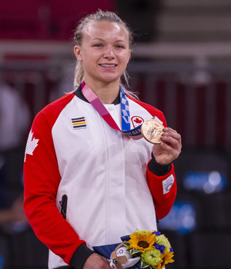

Athletes Sign-up: https://www.trackie.com/online-registration/register/judo-alberta-winter-camp/473573/

Coach Sign-up: https://www.trackie.com/online-registration/event/coach-sign-up-judo-alberta-winter-camp/473574/#.YYmS9mDMLic
Price: $55.00 U14/U16/U21/SR – Orange belt & Higher / No cost for club coaches
Location: Lethbridge Judo Club: www.lajudo.com
Judo Alberta Winter Camp Schedule
Friday December 3, 2021
6:00PM to 7:30PM Group 1
7:45PM to 9:15PM Group 2

Saturday December 4, 2021
9:00AM to 10:30AM Group 1
10:45AM to 12:15AM Group 2
Lunch
3:00PM to 5:00PM Group 1
5:15PM to 7:15PM Group 2
Pizza 6:30PM to 8:00PM

Sunday December 5, 2021
8:00AM to 9:00AM Circuits
9:30AM to 10:00AM Photos / Autographs / Group Photo
10:00AM to 12:30PM Technical & Randori
Camp schedule is subject to change

REGISTRATION DEADLINE: Monday November 29, 2021

Eligibility:
- Judo Alberta / Judo Canada Member
- Only participants over the age of 12 with proof of vaccination are permitted to double vaccinations will be required as per Government of Alberta regulation
- People with medical exemption (proof required)
- Unvaccinated participants need to have a negative rapid testing with 72hours are permitted to attend

Sponsored by Judo Canada & Judo Alberta
