Fall Coed Ladder and Fall Tournament Sign-up Instructions:

Please save for future reference.
- Go to www.pickleballbrackets.com.
- Click on the Blue ‘sign up’ button on the top right.

3. Enter your email address and click on the Blue ‘Get Started’ button.
4. Create an account by filling in your name and password. Please keep a record of your password. Then click on the Green ‘Get Started’ button.
5. The next screen will require you to go to your email account and open the email from pickleball brackets. When you open this email click on the Blue button “Click here to verify.

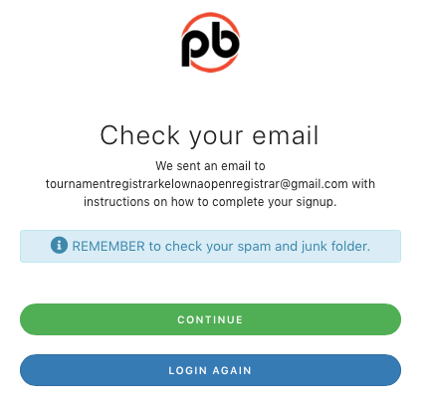
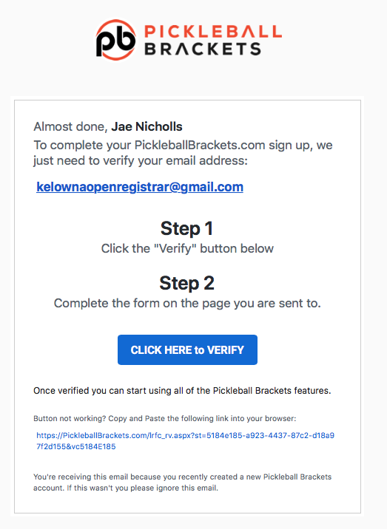
6. Once you verify please fill in information accurately as pickleball brackets is connected to Pickleball Canada and the information needs to be the same for both.

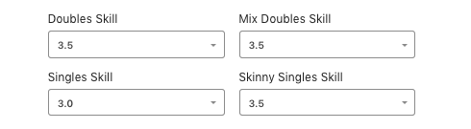
7. The Rating portion of this page is very important to understand.
This is your self-rated skill level and CPC will manage your club rating as it stands to date.

- The pickleball brackets rating system has a very sophisticated, transparent, Club Rating system based on 5 different factors for impacting ratings. You will be able to view game scores, your rating, the ratings of the other players, predicted outcomes and rating changes of all players. This is the same rating system that will be used by Pickleball Canada for tournament ratings going forward. Although CPC ladder/league play results will only be used for CPC Club Ratings, adopting the same rating system as our national system, streamlines and lends credibility to your club rating. If you want to work on changing your rating or would like to develop a club rating, playing in Performance-Based League Play is the only way to that. At this time CPC will not offer any other type of club rating.

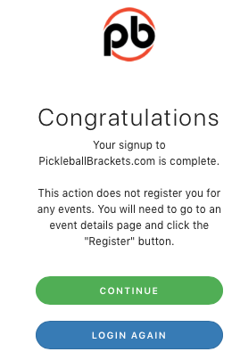

8. Once done click the Green button: Complete Account Setup

9. ‘Congratulations, your sign up is complete’ will be the next message. You have completed your pickleball brackets profile. Click on the Green continue button to sign up for Chilliwack Pickleball Club and our leagues.

10. You will need to login with your email address and password.

11. It will open the pickleball brackets home page and you will see your name in the far right upper corner.
12. Click on ‘Clubs” and search for Chilliwack Pickleball Club, the clubs are listed in alphabetical order.

13. Once you click on Chilliwack Pickleball Club you will see a tab that says “Become a Member”. Click on the button. You will then see a Blue button that says” Click Here Complete Your Request”.

14. You will now see “You’re Now a Member”. You can now sign up for Ladder/league play. You must be logged in to signup.

15. At the top of the page click on Leagues and search for Chilliwack Pickleball Club leagues. Click on the Green register button and then the next Green details button.

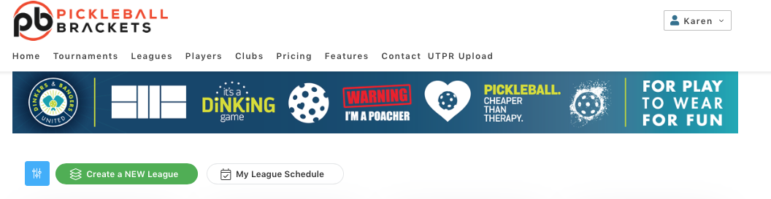
16. Click the Green “Click to Register”.

17. Click the Green “Click to find my partner”. (If this applies).

18. Search for partner. (If this applies).

19. Click Green “Select” (If this applies).

20. Click Green “ Next”.

21. Click the
Waiver box.

22. Click the Green “Finish Transaction” button.

23. You’re done and entered into a League.

I know and understand that this new ladder/league system requires you to follow a lot of instructions, however once players are more familiar things will run more smoothly. Thank you for your understanding and patience.

Wow! Thank you for registering !
If you still need help please contact Carol at secretary@chillpb.com for further assistance.

