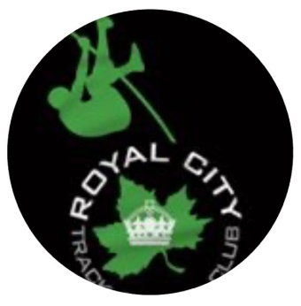
Royal City Track and Field
High Performance Vault Series
Sundays, 06 & 20 June, 04 & 25 July 2021
Participate in one or all of the meets.
Mercer Stadium 900 Sixth Street New Westminster BC email questions to imcoutts@telus.net
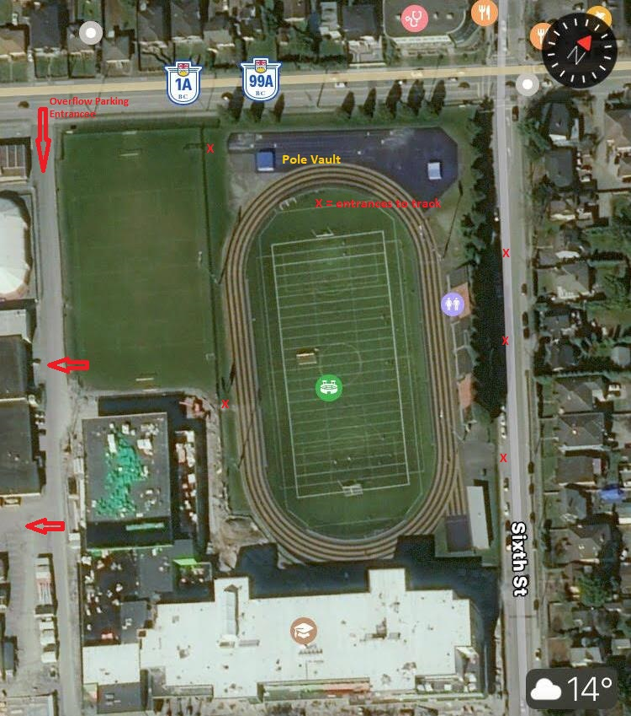
X = Entrance Gate
We have a new school on this site, impacting access and parking. There is no parking on 10th Avenue, and the east side of 6th Street is by permit only. If you are unable to park on the stadium side of 6th Street, there is ample parking around the old NWSS and the Pearson Centre, accessed from 10th Avenue between 6th and 8th Street. Please note you cannot turn left onto 6th Street if travelling west on 10th Avenue, you may however turn left into the parking lot. Some GPS and internet map services have an old address on 8th Avenue for Mercer Stadium; this will take you to the arena and Massey Theater and you can drive past the new school to park.
Access to the upper west gate is from the grass field or from beside the new school, not from the 10th Avenue sidewalk. Please respect any field sports being played.
If you experience difficulties call Ian 778 789 0338 for real-time directions.
HP CSI-P nominated athletes only, 10 participants maximum
10:30 Athlete Check In
10:45 Warm Up Vaults
12:00 First Flights
Athletes to bring their own chairs, towel, tarp or heavy blanket and water bottle etc. As social distancing will be maintained, there will not be an athlete tent set up.
Spectators will not be allowed in the jumps area under current restrictions. There is a grandstand which is a separate facility outside of our area, but it is on the other side of the track. Social Distancing must be maintained.
Single event meet, decision of the officials is final, disputes to be addressed to Sean Dixon or delegate within 30 minutes of the occurrence.
By registering your athlete your athlete you signed the following:
I attest that: • Participant has not travelled internationally in the past fourteen (14) days. • Participant has not travelled outside the Province of British Columbia in the last fourteen (14) days. • Participant has not travelled to an area highly impacted by COVID-19 within my Province in the past fourteen (14) days. • I have not and do not believe that Participant has been exposed to a person with a confirmed or suspected case of COVID-19. I attest that: • Participant has not been diagnosed with COVID-19 OR • Participant has been diagnosed with COVID-19 and been cleared as noncontagious by provincial or local public health authorities (confirmation from a medical practitioner will be required and maintained in a confidential file by the organization). Any changes in these answers between registration and the event will require the withdrawal of the athlete.

