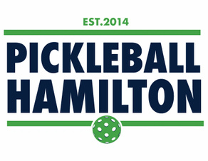
PICKLEBALL HAMILTON CODE OF CONDUCT

All members of Pickleball Hamilton agree to play the game with the upmost respect and consideration for other players and the environment
Specifically, all members of Pickleball Hamilton agree to the following:
I will always exhibit good sportsmanship and encourage others to do the same.
I will always conduct myself in a manner that promotes the health, safety, and well-being of others.
I will always use language and actions that are positive, encouraging, and supportive.
I will exhibit fairness and honesty in all dealings with others.
I will be a positive role model for others learning the game.
I will take an active role as an ambassador for Pickleball Hamilton in promoting the game as a fun activity for all ages.

