Presents
2020 Eastern Region Cross Country Championships

November 15

Lower Beverly Lake Park
146 Lower Beverly Lake Rd
Delta, ON
K0E 1G0

Technical Package

Table of Contents
Competition Details 3
Age Categories 3
Eligibility 3
Heat Assignment 4
Waiver 4
Course Map 4
Arrival and Departure 5
Health Precautions 5
Officials and Volunteers 6
General Information 7
Location 7
Contacts 8
Results 8
Photos 8
First Aid 8

Competition Details

Age Categories:
U10: born in 2011 or after
U12: born in 2009 or after
U14: born in 2007 or after
U16: born in 2005 or after
U18: born in 2003 or after
U20: born in 2001 or after
Open: born in 2000 or before
Masters: on November 15, 1990 or before

Eligibility: There are no entry standards for this meet.

Athletes residing in Ontario must be registered, and their clubs affiliated, with Athletics Ontario for the 2020 season by the Late Entry Deadline. Athletes not registered with Athletics Ontario by the entry deadline will be subject to a late registration fee, in addition to the regular membership and championship event entry fees, payable to Athletics Ontario prior to picking up their bib number. Athletes registered with Athletics Ontario as “Unattached” or “Disassociated” do not require a club affiliation.

Athletes residing in Ontario but representing a club from outside the province must be registered with their association and must be entered by their respective clubs.

Athletes residing outside of Ontario or Canada should be registered with their provincial or state associations for the 2020 indoor season. Athletes from other countries will need to contact Randolph Fajardo, randolphfajardo@athleticsontario.ca, in order to be entered into the
competition. Please ensure you have your membership number from your local athletics governing body.

Entry Deadline: Wednesday, November 11, 11:59pm EST for AO competitive members. After closing, and the entries have been reviewed, and deemed that there is space available to accept late entries, college and University groups will then be able to register with AO as an Unattached Competitive athlete at a discounted rate of $25, and entry will be re-opened to allow additional entries until 11:59pm EST on Thursday, November 12.

Fees: Entry to the event is $25

Heat Assignment: Starts will have athletes run in heats of 10. These will be seeded based on entry times.

Heat assignments will be posted the day before the event.

Waiver: Every participant is required to sign the waiver form on each respective event website (see links at the beginning of this document). For athletes under the age of 18, a parent or guardian’s signature must appear on the waiver. Clubs that have POA can find a club POA waiver on the event website as well.

Course Map: To be added by Wednesday November 11th.

COVID-19 Plan (Regulations)
Due to COVID-19, please arrive before and depart just after your race. Maintain physical distancing at all times. All precautions are outlined below. A maximum of one spectator per athlete please.

Arrival and Departure: Athletes will be allowed to arrive at the competition site 15min prior to the start of their event to continue/complete any warmups before the start of the race.

Athletes must leave the competition area after completing their event. Spectators must also leave the competition area once the athletes they have arrived with have completed their event.

Health Precautions: Athletes are asked to do any warmups in marked areas away from the course to keep the number of individuals at the competition site to an absolute minimum. Athletes may jog in the park but are asked to stay away from the start/finish area until their allocated arrival time.

Wearing a mask is highly recommended. It is expected that spectators/coaches/athletes bring their own face masks. It is mandatory if you are unable to maintain 2m between other individuals at the event. Entry to the competition area will be prohibited if proper face coverings are not brought by participants.

A hand sanitizer station will be available by the registration/finish line area. It is recommended for all participants to bring their own PPE and hand sanitizer to minimize touch points while at the competition.

Please ensure that athletes are maintaining a minimum 2m distance between each other during the warm-up period.

When greeting or congratulating others at the competition, please refrain from any physical contact such as high fives or hugs.

Equipment brought to the competition site should be kept to an absolute minimum. If you arrive by car, it is recommended to keep all equipment such as backpacks, water, snacks in the vehicle and then leave to warm-down in an alternate site after the competition is complete.

Coaches and spectators will need to register if they plan to attend any of the events. Links to register can be found on each individual event page. Anyone that does not register will not be allowed on premise.

There will be no awards ceremonies at the competition. Any awards will be mailed to participants.

Officials and Volunteers: Additional regulations that will be utilized at the events by officials and volunteers can be found here: https://athleticsontario.ca/wp-content/uploads/2020/07/AO-Running-Race-Risk- Assessment-and-Safety-Protocols-v5.pdf

General Information
Location:
146 Lower Beverly Lake Rd
Delta, ON K0E 1G0

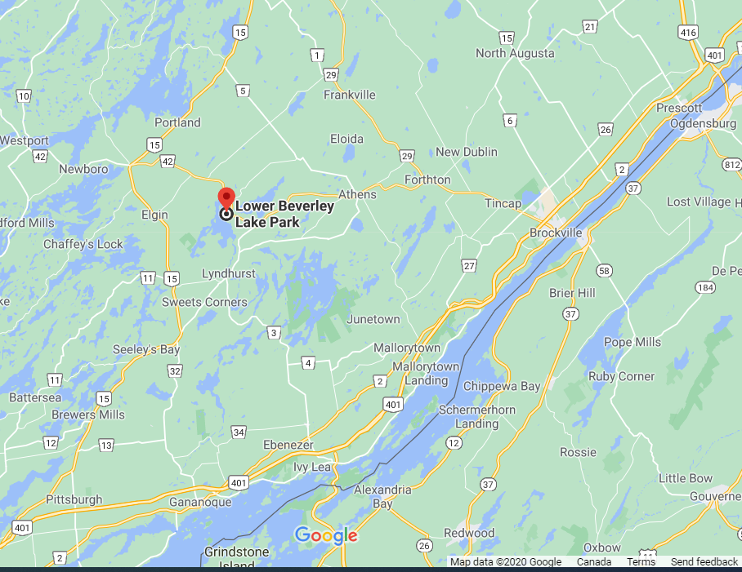

Contacts:
Meet Director | Laura Sivers | brockvillelegiontrack@gmail.com

Results: Results will be posted on the Monday following the competition.
Please click on the following link for the meet results. https://athleticsontario.ca/stats/results/

Photos: Photos captured by the Athletics Ontario/Brockville Legion team will be posted on the Athletics Ontario social media sites (Facebook, Twitter, Instagram, etc.) during and following the meet. All athletes are given the opportunity to sign a waiver/release form regarding photography. Facebook page: https://www.facebook.com/Athletics-Ontario-135196239850966/?fref=ts

First Aid: The closest hospital is as follows:
Brockville General Hospital
75 Charles St
Brockville, ON K6V 1S8
613-345-5649

