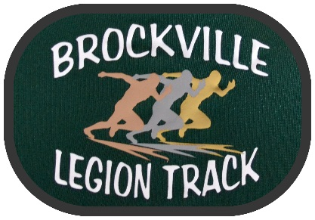

4th Annual Leeds and Grenville Youth

XC Championships

Hosted by Brockville Legion Track and Field Club

Date: Saturday October 24th, 2020

Location: Memorial Park, Brockville. Parking is accessible ONLY from 473 Laurier Blvd. There is NO Access to the Brockville Memorial Centre.

Age Classes: M/F U10 (2011/2012) – 2k U10/U12 may be combined

M/F U12(2010/2009) – 2k

M/F U14(2008/2007) - 3k

M/F U16(2006/2005) - 4k

M/F U18(2004/2003) -5k
M/F U20/Open (2002 and earlier) - 6k

Entry Fee: $ 15 Registration is online at www.trackie.reg/LGYXC2020 Payment must be made online.

Deadline: All online entries must be received by 4:00pm on Thursday Oct 22nd

Waiver: Waiver forms must be accepted as part of registration. This meet is only open to athletes who are registered members of Athletics Ontario.

Check-in and Bib Pick-up: Health Screen and sign in will be confirmed 45min-30min before your start time. Meet start is 9:30am.

Final Schedule to be posted Thursday October 22nd

Questions: Coach Laura Sivers brockvillelegiontrack@gmail.com

COVID Protocols:
- Each race will be run in heats of 10 athletes, with 10 minutes between each start.
- There is a maximum entry of 40 athletes per age category to ensure that gathering limits are not exceed
- Athletes must warm up away from start/finish lines and only attend come to the start when called.
- Masks are to be warn to the start line and only removed once instructed by the starter. Masks must be carried on the athletes person and be replaced immediately upon entering the finish area.
- Athletes must complete an online health check on the day of the health check and have no symptoms, and have been symptom free for the past 14 days, or have had a negative COVID check and been sympton free for a minimum of 24 hours.
- Athletes from regions of the province currently in Stage 2 protocols or in “RED” status will not be allowed to compete, please do not register. Addresses will be checked. As of this publication, that includes Ottawa, Toronto and Peel Health Regions.
- Only one spectator is allowed to attend the meet with an athlete and must fill out a health check on the day of the event as well as the athlete
- Remain 2m apart from other coaches, spectators and athletes at all times. Passing must be done wide a quickly. Drafting will be given one warning and will then result in disqualification.
- Masks must be worn by parents and coaches at all times while at this event.

Please arrive for your event, check-in, compete and leave. Results will be posted after the event and awards mailed.
There will be t-shirts for the top 3 finishers and top team in each event.

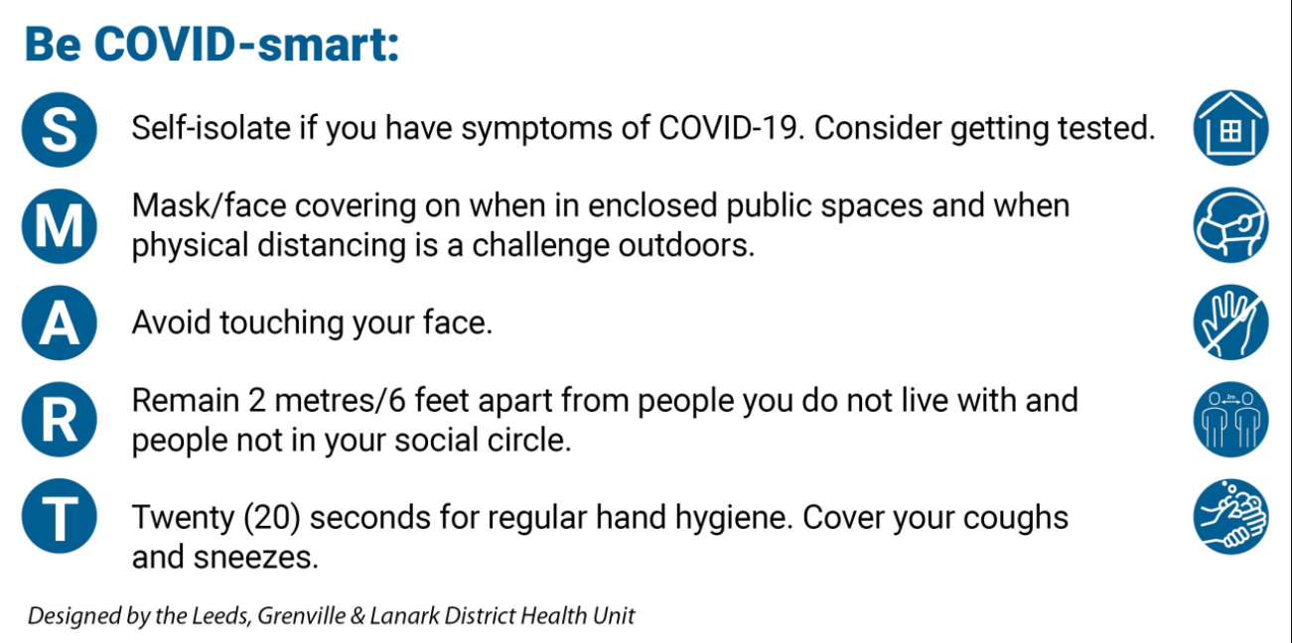

BROCKVILLE LEGION TRACK AND FIELD

WAIVER AND RELEASE OF LIABILITY FORM
(ASSUMPTION OF RISK, RELEASE OF LIABILITY, WAIVER OF CLAIMS AND INDEMNITY AGREEMENT)
By signing this document you will waive certain legal rights, including the right to sue
ASSUMPTION OF RISK

- I, the undersigned, wish to participate in Cross Country. I recognize and understand that Cross Country (hereinafter called ‘XC’) involves certain risks. Those risks include, but are not limited to, the risk of injury resulting from possible malfunction of equipment used in XC and injuries resulting from tripping or falling over obstacles. In addition, I recognize that the exertion of XC could result in injury or death.

- Despite these and other risks, and fully understanding such risks, I wish participate in XC and hereby assume the risks of XC. I also hereby hold harmless the 'Sponsors' and indemnify them against any or all claims, actions, suits, procedures, costs, expenses (including legal fees and expenses), damages and liabilities arising out of, connected with, or resulting from my participating in XC, including, without limitation, those resulting from the manufacture, selection, delivery, possession, use or operation of any and all equipment used in XC. I hereby release the Sponsors from any and all such liability, and I understand that this release shall be binding upon my estate, my heirs, my representatives and assigns. I hereby certify to the Sponsors that I am in good health and do not suffer from a heart condition or any other ailment which could be exacerbated by the exertion involved in participating in XC. I further certify that I am 18 years of age or older.

RELEASE OF LIABILITY, WAIVER OF CLAIMS AND INDEMNITY AGREEMENT
In consideration of participating in Track, I hereby agree as follows:

- TO WAIVE ANY AND ALL CLAIMS that I have, or may in the future have, against

Brockville Legion Track Club Athletics Ontario

their directors, officers, employees, agents and representatives (all of whom are hereinafter collectively referred to as ‘the Releasees’’);

- TO RELEASE THE RELEASEES from any and all liability for any loss, damage, injury or expense that I may suffer, or that my next of kin may suffer as a result of my participation in XC due to any cause whatsoever, INCLUDING NEGLIGENCE ON THE PART OF THE RELEASEES;
- TO HOLD HARMLESS AND INDEMNIFY THE RELEASEES from any and all liability for any damage to property of, or personal injury to, any third party, resulting from my participation in XC;
- That this Agreement shall be effective and binding upon my heirs, next of kin, executors, administrators and assigns, in the event of my death.
PLEASE READ CAREFULLY

I HAVE READ AND UNDERSTOOD THIS AGREEMENT, AND I AM AWARE THAT BY SIGNING THIS AGREEMENT I AM WAIVING CERTAIN LEGAL RIGHTS WHICH I OR MY HEIRS, NEXT OF KIN, EXECUTORS, ADMINISTRATORS AND ASSIGNS MAY HAVE AGAINST THE RELEASEES.
Date: ______________________________________

Participant name ____________________________________________
(Please print)

Signature of parent or legal guardian __________________________________

