PHOENIX ATHLETIC 800 / 100/400 nite Event Info
Sunday August 2rd, 2020

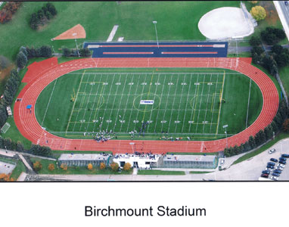
Tentative Schedule – Meet may run up to 15 min ahead of schedule.
Track Events
4:30 pm Event #1 Women’s 800m
4:30 pm Event # 2 Men’s 800m
5:45 pm Women’s 1000m invite
6:00 pm Event # 3 Women’s 100m
6:00 pm Event # 4 Men’s 100m
7:00 pm Event # 5 Women’s 400m
7:00 pm Event # 6 Men’s 400m
Field Events
3:00 pm Event # 8 - 7 Men’s / Women’s Javelin
4:45 pm Event # 10 - 9 Men’s / Women’s Shot Put
6:30 pm Event # 12 - 11 Men’s / Women’s Discus
“All Athletes must be registered with Athletics Ontario”

Athletes should bring their own Discus, Shot Put and Javelin to the competition sight

Awards: t-shirt for the winner of each Event.
.
Results: Will be posted on Trackie.
Comp Numbers: Be sure that each athlete has the correct competitors number pin to the front of their
racing top.
Entries : Any entry or results problem see Alan Baigent at the finish line tent.

