Date: Saturday January 4th, 2020
Location: University of Toronto Field House
Faculty of Kinesiology & Physical Education
55 Harbord Street

Start Time: Saturday 8:00 am
Sanctioned by: Ontario University Association (OUA)
Hosted By: Faculty of Kinesiology & Physical Education
University of Toronto Track and Field Club

Meet Director: Bob Westman – bob.westman@utoronto.ca

Eligibility: University, College, and AO athletes

Entries: Must be submitted on-line by Thursday Jan 2nd, 2020(noon)

http://www.trackie.com/online-registration/

Cheques: Cheque Payable to: University of Toronto
Facility: 200m flat Mondo - rubber 5-lane track with 8 sprint lanes. All runways Mondo - rubber; shot put circle concrete.
Spikes: MAXIMUM 6mm.
Timing: Fully electric timing.
Changing facility: Locker rooms are available for men and women. Please bring your own locks and towels.
Entry Fee: $20.00 per athlete per event
Cost limit $500 per team
Late Entry: Late entries will be accepted at $40.00 per athletes per events.
Entries will not be accepted after 6:00PM the night before the meet.
SCRATCHES: Please make all scratches online or upon arrival to the Field House registration desk (top of the stairs).

Track Events | Final  Meet Schedule  SATURDAY January 4th, 2020
11:00 AM | 60m hurdles heats (2) | Women
11:05 AM | 60m hurdles heats (1) | Men
11:10 AM | 60m heats (6) | Women
11:30 AM | 60m heats (8) | Men
11:55 AM | 1000m timed section (1) | Women
12:00 PM | 1000m timed section (2) | Men
12:15 PM | 4x200m relay (2) | Women
12:25 PM | 4x200m relay (2) | Men
12:35 PM | 1200M timed section | Women
12:40 PM | 1200M timed section | Men
12:50 PM | 1500m times sections (1) | Women
12:55 PM | 1500m times sections (2) | Men
 | Track Break
1:40 PM | 60m hurdles final (1) | Men
1:45 PM | 60m hurdles final (1) | Women
1:55 PM | 60m final (A+B Final) (2) | Men
2:00 PM | 60m final (A+B Final) (2) | Women
2:10 PM | 600m timed sections (3) | Women
2:25 PM | 600m timed sections (4) | Men
2:45 PM | 300m timed sections (10) | Women
3:15 PM | 300m timed sections (11) | Men
3:50 PM | 3000m times sections (1) | Women
4:05 PM | 3000m times sections (1) | Men
4:25 PM | 4x800m timed sections (1) | Women
4:35 PM | 4x800m timed sections (1) | Men
4:45 PM | 4x400m timed sections (1) | Women
4:50 PM | 4x400m timed sections (2) | Men

Field Events | Final  Meet Schedule  SATURDAY January 4th, 2020
8:00 AM | Weight Throw (7 + 2) | Mens + Womens
8:45 AM | Shot Put (12 + 3) | Mens + Womens
11:00 AM | Long Jump (20) | Men
11:00 AM | High Jump (7) | Men
11:30 AM | Pole Vault (9) | Womens
1:00 PM | Long Jump (16) | Women
2:00 PM | Pole Vault (8) | Men
2:00 PM | High Jump (8) | Women
3:00 PM | Triple Jump (7) | Men
4:30 PM | Triple Jump (10) | Women

NEW For the University of Toronto Athletic Centre Field House
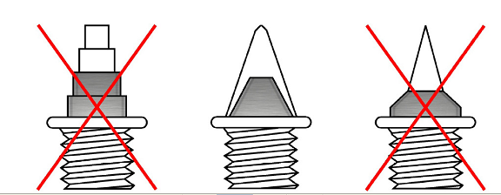

SPIKES
- All spikes must be presented to be checked at the spike check in table (where you receive your hip numbers)
- Athletes will not be allowed to compete without having their spikes
checked and cleared .
- Acceptable spikes: 6mm pyramids / cones – same size
- Any athletes competing with longer than 7mm spikes will be disqualified.
- Water is the only permitted drink allowed on the track facility.

