**Date:** Mar 14, 2020 10 am – 5 pm

Mar 15, 2020 9 am – 4 pm

**Location:** Irving Oil Field House

129 McAllister Dr., Saint John NB

**Meet directors:**

Bill MacMackin [Saint](mailto:Saint)JohnTrack@gmail.com

Meet registration will be done online through: [www.trackiereg.ca](http://www.trackiereg.ca) or visit [www.anb.ca](http://www.anb.ca). no later than Mar 12 No late entries will be accepted

**FEES:** $25.00 for first event & $10 for each additional event. Late fees may apply after early registration cut off.

-No Starting Blocks for Athletes in the U12 & U14 age class

Ribbons will be available for the top three (3) in each category U18 & Younger in each event.

Some events might be combined with age classes and sexes if the numbers justify it (results will be separated).

U12 age athletes compete in the Tetrathlon event (60m, LJ, SP, 600m) on Sunday March 15, 2020

**Date:** 14 mar, 2020 – 10 am – 5 pm

15 mar, 2020 – 9 am – 4 pm  
**Lieu :** Irving Oil Field House

129 McAllister Dr., Saint John NB

**Directeurs de rencontre:**

Bill MacMackin [Saint](mailto:bill@selectfh.ca)JohnTrack@gmail.com

L’inscription es trouvé en ligne : www.trackiereg.ca ou visitez [www.anb.ca](http://www.anb.ca) avant le 12 mar.

Aucune inscription après cette date sera acceptée.

**Frais**: 25,00 $ pour le premier événement et 10$ pour chaque événement supplémentaire. Des frais de retard peuvent s'appliquer après l'inscription coupée.

Pour les catégories U12 et U14, aucuns blocs de départ ne seront permis.

Si le nombre de participants l'exige, il y aura regroupement des catégories et des sexes pour les événements de piste. Les résultat seront cependant séparés.

Les athlètes U12 doivent prendre part à l'épreuve du Tetrathlon (60m, saut en longueur, lancer du poids, et 600m) – 15 mar, 2020

**TENTATIVE Combined schedule of events for this championships which is two meets in one.**

**It includes the Atlantic Championships for clubs and Canadian Masters Indoor Champs.**

**(Subject to change based on entries)**

**HORAIRE PRÉLIMINAIRE DES ÉPREUVES (Sujet à des modifications)**

L’horaire complet sera disponible le jour avant de la compétition



**HOTELS/ACCOMMODATION**

* These hotels are each less than a 20-minute drive by car or taxi from the Saint John Airport, and less than 6 minutes from the Irving Oil Field House.



* $129.99 for up to 2 people in a room and $139.99 for 4 people in the room
* Reservations must be made by calling 1-506-[657-9966](https://www.google.com/search?sxsrf=ACYBGNSMHBmnBrxuk3petJ_jbwp9pUbIdw%3A1568540800153&source=hp&ei=gAh-XefpBqHW5gKogZrACQ&q=best+western+saint+john&oq=best+wester+sai&gs_l=psy-ab.3.0.0i10l10.861660.863991..865020...0.0..0.120.1444.10j5......0....1..gws-wiz.......0j0i131.-gR81WjWUNw)
* **55 Majors Brook Drive, Saint John, New Brunswick E2J 0B2**

* $149.00 per room **[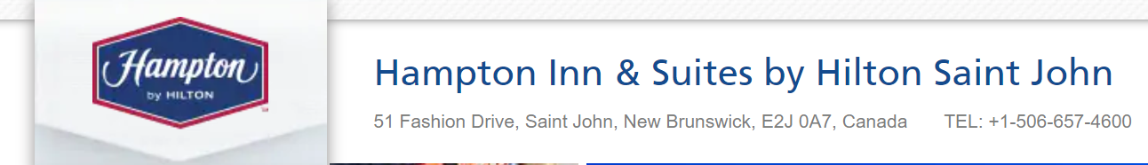](https://hamptoninn3.hilton.com/en/hotels/new-brunswick/hampton-inn-and-suites-by-hilton-saint-john-YSJSJHX/index.html)**
* Book online using promo Code – CMI
* **51 Fashion Drive, Saint John, New Brunswick E2J 0A7** [**Web Reservations**](https://hamptoninn3.hilton.com/en/hotels/new-brunswick/hampton-inn-and-suites-by-hilton-saint-john-YSJSJHX/index.html)