2019

CROSS COUNTRY
NATIONAL

CHAMPIONSHIP

SECTION 1:
08
Fall

GENERAL INFORMATION

1. ORGANIZING COMMITTEE

Address: 284 Earl Street, Kingston, ON, K7L 3N6

Phone: (613) 533-6000

Fax: (613) 533-6478

Web Site: www.gogaelsgo.com
POSITION | NAME | PHONE | E-MAIL
Committee President | Sean Scott | Ext. 79110 | sean.scott@queensu.ca
Athletic Director | Leslie Dal Cin | Ext. 74720 | athletic@queensu.ca
Coordinator | Lana Unsworth | Ext. 33326 | Lana.unsworth@queensu.ca
Student-athlete services | Cassandra de Bartok | Ext. 79183 | cassandra.debartok@queensu.ca
Medical services | Ryan Bennett | Ext. 75334 | ryan.bennett@queensu.ca
Sponsorship | Lana Unsworth | Ext. 33326 | Lana.unsworth@queensu.ca
Communications | Shawn MacDonald | Ext. 36990 | Shawn.macdonald@queensu.ca
Logistics - event | Matteke Hutzler | Ext. 77834 | homevent@queensu.ca
Ticketing | Kelly Smith | Ext. 74728 | coord.sales@queensu.ca
Awards & Ceremonies | Larissa Mankis | Ext. 74731 | larissa.mankis@queensu.ca
U SPORTS - Manager National Champs | Scott Ring | 905-508-3000 #244  Cell : 416-553-6121 | sring@usports.ca

2. SCHEDULE OF EVENTS
*All times are local

Friday November 8th
9:00 – 11:00 AM Welcome Breakfast
11:00 – 12:30 PM Technical Meeting
12:30 – 2:30 PM Coaches Association Meeting
3:00 – 6:00 PM Training and Site Visit

Saturday November 9th
10:00 AM – 12:00 PM Warm-up and Training
1:00 PM Women’s Race – 8 KM
2:00 PM Men’s Race – 10 KM
3:30 PM Awards Presentation

3. COMPETITION SCHEDULE

Saturday November 9th
1:00 PM Women’s Race
2:00 PM Men’s Race

4. PRACTICE SCHEDULE

Friday November 8th
3:00 – 6:00 PM Training and Site Visit

Saturday November 19th
10:00 AM – 12:00 PM Warm-up and Training

SECTION 2

DETAILED INFORMATION – PARTICIPANT SPECIFIC

1. PARTICIANT TEAM & ALL-CANADIAN FUNCTION/SPECIAL EVENTS

WELCOME BREAKFAST
Date: Friday November 9th
Site: Ramada Hotel and Conference Centre – Cartier Ballroom
Cost: $35.00 (max team complement of 9)
Schedule: 9:00 – 11:00 AM
Dress: Business
Additional Tickets: $40.00
Distance from Hotel: On site
R.S.V.P. before: Monday November 4th by 12:00 PM

Student-Athlete Team Introduction / Interview (Banquet):
Please be advised that each participating team will have a brief opportunity to share with the audience their “Road to Success”. Please indicate who your student leader will be from each team, as they will be interviewed about the key highlights from their season that led them to qualify for the USPORTS Championship. This is to be approx. 3-5 min in duration and we would request that each team provide us with 2-3 PowerPoint pictures (emailed to SID comm.sio@queensu.ca), to be displayed while the interview is being conducted. Please provide us with the name of your athlete on the banquet form so we can prepare the script for the banquet. We will provide the questions in advance.

PARTICIPANT CLOTHING ORDER:
Souvenir long sleeved T-shirts are available for purchase to race participants by ADVANCE ORDER ONLY. If your team would like to purchase the shirt please complete Section 2 of the Team Order Form indicating the number and sizes. Payment method will be provided in the next bulletin.

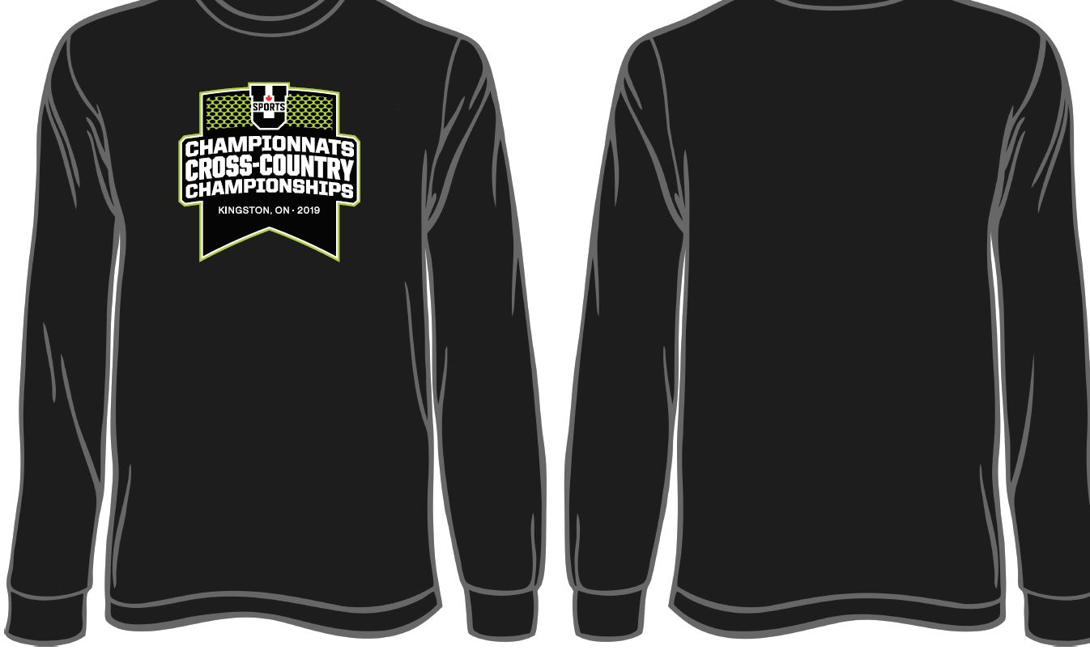

2. MEETINGS
TECHNICAL MEETING
Date: Friday November 8th
Time: 11:00 – 12:30 PM
Location: Ramada Hotel and Conference Centre
Room: Cartier Ballroom
COACHES ANNUAL MEETING
Date: Friday November 8th
Time: 12:30 – 2:30 PM
Location: Ramada Hotel and Conference Centre
Room: Cartier Ballroom

TEAM MEETING ROOMS:
One meeting room will be made available at the host hotel during the championship. A booking system at the hotel will be utilized to schedule the use of these rooms. AV will be included in these locations.

3. MEDIA INFORMATION & ACCREDITATION

- MEDIA CONFERENCE

There will be no scheduled media conference prior to the championship. Shawn MacDonald, Sports Information Officer, will be in contact with participating teams for specific media requests. Media kits are to be provided for all media at the event.

- MEDIA ACCREDITATION

To request media accreditation, please contact Shawn MacDonald at shawn.macdonald@queensu.ca, prior to Monday November 4th, 2019. Media passes may be picked up on site at the will call if pre-arranged.

4. CHAMPIONSHIP HOTEL

U SPORTS policy 20.40.3.4.1:
All participating teams and team personnel attending a U SPORTS Championship requiring accommodation must stay at the U SPORTS Championship designated host hotel.

Host Hotel: Ramada Hotel and Conference Centre

Address: 33 Benson, Street, Kingston ON

Phone: 613-546-3661

Fax: 613-544-4126

Email: sromero@diamondhotels.ca

Contact Person: Sarita Romero

Group Block Name: 2019 Cross Country Championships

Room Rates: $129.00 per room, per night plus applicable taxes including breakfast.

Distance from Competition Site: 6.8 km

Parking: On site free parking

Secondary Hotels

Hotel: Comfort inn Hwy 401

Address: 55 Warne Crescent, Kingston, ON

Phone: 613-546-9500

Email: janet.chapman@innvesthotels.com

Contact Person: Janet Chapman

Group Block Name: 2019 Cross Country Championships

Room Rates: $109.00 per room, per night plus applicable taxes including breakfast

Distance from Competition Site: 7.2 km

Parking: On site free parking

Hotel: Holiday Inn Kingston Waterfront
Address: 2 Princess Street, Kingston, ON
Phone: 613-549-8400
Email: Caitlin.mccallum@innvesthotels.com
Contact Person: Caitlin Mccallum
Group Block Name: 2019 Cross Country Championships
Room Rates: $135.99 per room, per night plus applicable taxes. Breakfast
not included
Distance from Competition Site: 2.3 km
Parking: Comp team bus parking. On site paid parking for all other vehicles.

5. TRANSPORTATION

Name of Company: McCoy Bus Service (Coach Transportation)
Address: 566 Cataraqui Woods Drive, Kingston, ON K7P 2Y5
Telephone: (613) 507-5566 or (866) 384-0012
Contact: Nicole Neumann

Name of Company: Martin’s Bus Service Ltd. (School & Activity Buses)
Address: 106 Advance Avenue, Napanee, ON K7R 3Y5
Telephone: (613) 354-7545 or (800) 831-6872
Contact: Melissa Yoemans

Name of Company: Dixon’s Car & Truck Rental
Address: 2392 Princess Street, Kingston, ON K7M 3G4
Telephone: (613) 542-2222 or (877) 332-7070
Contact: Michael Plant

6. TEAM REGISTRATION AND ACCREDITATION
Race Registration: Race registration will be online at Trackie.ca.

http://www.trackiereg.com/USportsXC19

Accreditation:
Provided at the Host Hotel when you arrive. Included will be the number of accreditation passes based on the Team Order Form completed by each team.

Any additional accreditation passes must be requested in advance of the championship.

Please forward your requests to Megan McGuire, sportev@queensu.ca prior to Monday November 4, 2019 at 12:00 PM.

7. TEAM SERVICES

A. TEAM HOST: Host will be on site at the host hotel

B. TEAM MEETING ROOM: Available for booking at the host hotel

8. SPONSORSHIP

8.1 Please support our U Sports sponsors. We encourage hosts and participating teams to help grow these important partnerships.
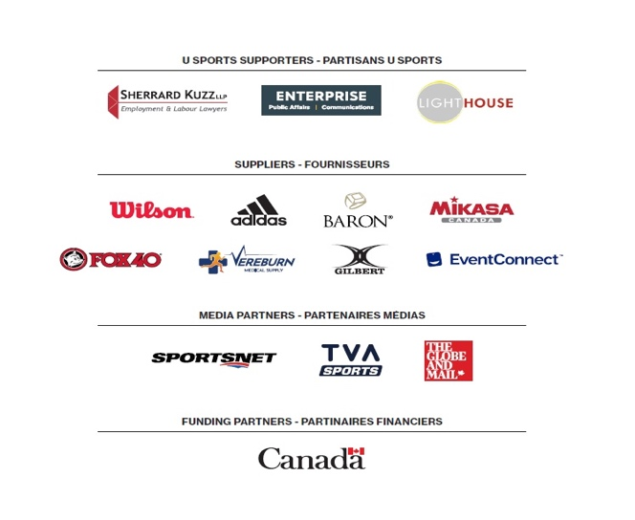
We encourage hosts and participating teams to help grow these important partnerships.

B. LOCAL SPONSORS

9. TECHNICAL INFORMATION

9.1 FACILITIES:

Course Description: The competition will be held at Fort Henry in Kingston, ON. The course is on a naturally winding, rolling grass surface, composed of small hills and flat sections. The course is situated on a very exposed hill so it could be windy.

Venue Name: Fort Henry
Competition Dates: November 10th, 2018
Address: 1 Fort Henry Dr, Kingston, ON K7K 5G8
Website: https://www.forthenry.com/
Phone: 613-542-7388
Parking Information: Free parking available at the Discovery Centre
*any vehicles parked on the hill will be towed
Parking Map:

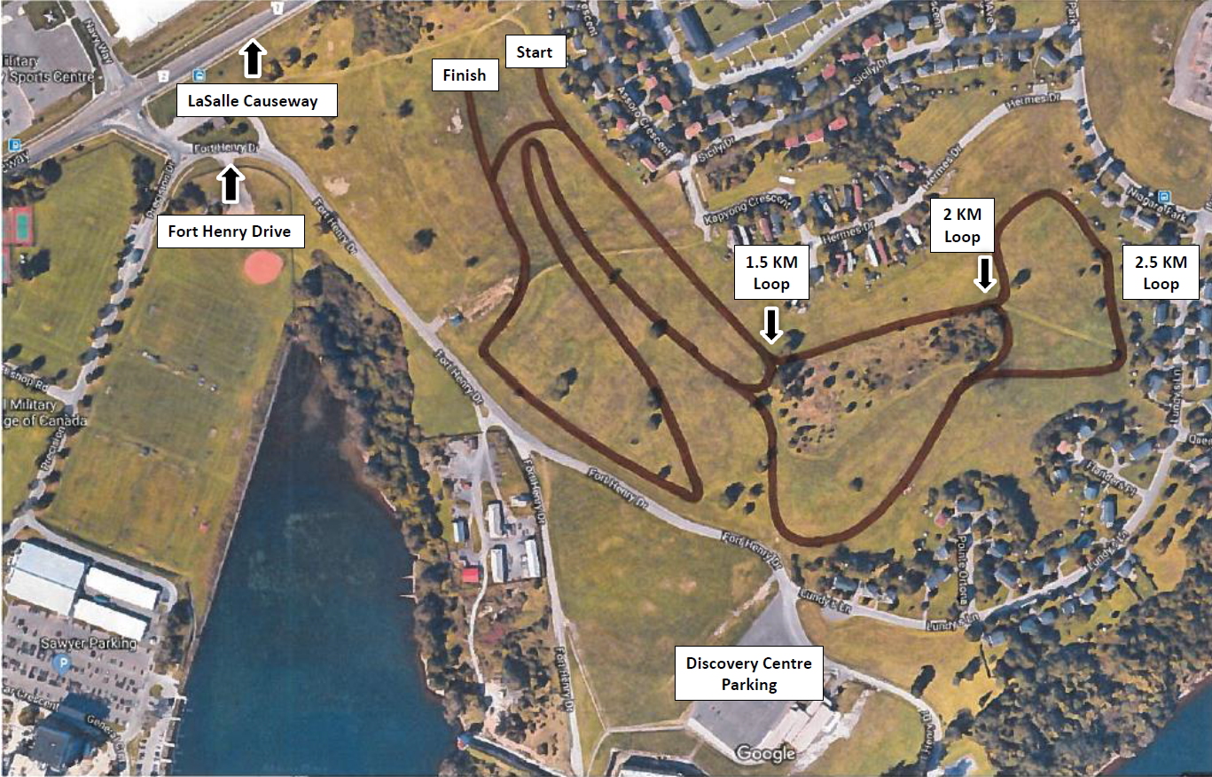

Washrooms: Portable toilets available on site.

Water: Limited water will be made available to athletes on race day. There is no direct access to running water at the site and teams will not be able to fill water jugs at the site. There will be a water buggy on site.

Parking: Parking available at the Fort Henry Discovery Centre. Please note, that you will be towed if you park on the side of the road.

9.2 EQUIPMENT: Speed River Timing will provide all on-site timing.

9.3 THERAPY / MEDICAL SERVICES:

Medical coverage (physician and certified Athletic Therapist) will be provided at the championship venue on competition day. Manager of Sport Therapy Ryan Bennett will be coordinating the medical coverage.

Further details will be provided to all teams at the Technical meeting.

10. AWARDS

The awards presentation will be held inside at the Discovery Centre (top of Fort Henry Hill) at 3:15pm. Coffee and hot chocolate will be provided.

1st and 2nd Team All Stars and Coaches of the Year will be presented at the awards ceremony, but the certificates will be mailed to the school the week after the race.

11. HOSPITALITY ROOMS
- VIPs/COACHES

11.1 VIPs/COACHES:
Hospitality tent will be set up with refreshments on site on race day.

11.2 ATHLETE NUTRITION ROOM:
Post-race nutritious will be available for participants at the finish line. Warm beverages will be available at the awards ceremony, at the Discovery Center following the men’s race.

SECTION 3

THE FANS CORNER

1. CITY GUIDE

A. ABOUT THE CITY

At the gateway of the 1000 Islands and the UNESCO-designated Rideau Canal, Kingston is a city rich in history and culture and home to a vibrant arts, food and maker community. We’re a city built on a grand heritage and defined by our ability to blend the beauty of yesterday with the passion and sophistication of today.

B. ATTRACTIONS https://www.visitkingston.ca/events/

C. RESTAURANTS & BARS https://www.visitkingston.ca/eat-drink/

Name | Location | Distance from venue | Type | Comments
The Grizzly Grill | 395 Princess St, Kingston, ON K7L 1B9 | 3.3 KM | Restaurant
The Union Kitchen | 184 Princess St, Kingston, ON K7L 1B1 | 2.8 KM | Restaurant
Pita Pit | 421 Princess Street, 108 Dalton Ave | 3.4 or 7KM | Restaurant
Gabriel Pizza | 339 Princess Street | 3.2 KM | Restaurant

D. EXPERIENCES & UPCOMING EVENTS

https://www.visitkingston.ca/

2. FAMILY & FRIENDS ACCOMMODATIONS

Holiday Inn Kingston Waterfront
Address: 2 Princess Street, Kingston, ON
Phone: 613-549-8400
Email: Caitlin.mccallum@innvesthotels.com
Contact Person: Caitlin Mccallum
Group Block Name: 2019 Cross Country Championships
Room Rates: $135.99 per room, per night plus applicable taxes. Breakfast
not included
Distance from Competition Site: 2.3 km
Parking: Comp team bus parking. On site paid parking for all other vehicles.

Ambassador Hotel and Conference
Address: 1550 Princess St, Kingston, ON K7M 9E3
Contact: Jonathan Rebelo
Email: jonathan.rebelo@ambassadorhotel.com
Phone: 613-541-4684

3. TICKETING INFORMATION
Free event

4. ON-SITE FAN INFORMATION

A. ACCESS & PARKING Free parking available at the Fort Henry Discovery Centre. Please note, that you will be towed if you park on the side of the road.

- SERVICES: Washrooms, limited services due to the location of the course.

- OTHER

Team Order & Information Form
Please complete and return to Megan McGuire, sportev@queensu.ca prior to November 4, 2019 by 12:00 PM ET
SCHOOL | HEAD COACH | EMAIL | CELL PHONE

- ACCREDITATION & WELCOME BREAKFAST

ACCREDITATION
Participants will be required to wear accreditation passes. Please indicate how many accreditation passes your team will require.

Please list the names and positions of anyone attending the races other than team personnel (athletic directors, VIPs).

WELCOME BREAKFAST
Friday November 8, 9:00 AM – 11:00 AM
Tickets are $35.00/person up to 9 athletes and coaches per gender per school. Additional tickets (above 30) may be purchased for $40.00/person.

Please list any allergies of those attending the award gala.

_________________________________________________________________

________________________________________

________________________________________

Item | Quantity | Price | Total
Athlete accreditation passes
Coach accreditation passes
Therapy accreditation passes
VIP accreditation passes
Total Accreditation Passes
Team Complement Welcome Breakfast tickets (up to 9 per team) |  | $35.00 | $
Additional Welcome Breakfast tickets |  | $40.00 | $
Total Welcome Breakfast Tickets |  | Total $ | $
TOTAL |  |  | $

WELCOME BREAKFAST PAYMENT METHODS:

Information for payment options will be provided in the next bulletin.

- CHAMPIONSHIP SOUVENIR

PARTICIPANT SOUVENIR DETAILS
Souvenir long sleeved T-shirts are available for purchase to tournament participants. Deadline date to order: Monday November 5 2018 by 12:00 PM ET
Item | Size | Quantity | Price | Total
Championship Souvenir Shirt | Youth S |  | $30.00 | $
 | Youth M |  | $30.00 | $
 | Youth L |  | $30.00 | $
 | Youth XL |  | $30.00 | $
 | Adult XS |  | $30.00 | $
 | Adult S |  | $30.00 | $
 | Adult M |  | $30.00 | $
 | Adult L |  | $30.00 | $
 | Adult XL |  | $30.00 | $
Total Shirts |  |  |  | $

CHAMPIONSHIP SOUVENIR PAYMENT METHOD:
Information for payment options will be provided in the next bulletin.

- TRAVEL INFORMATION

TRAVEL
Date & Time of Arrival:

If by Ground Transport: | Type:  Approximate arrival of time at Hotel:
If by Air: | Landing at:  Approximate arrival of time at Hotel:
To assist in planning the Championship, we would like to know your travel plans. Please fill out the form below.
- TEAM INFORMATION

We will have an interactive environment for the banquet. We are requesting you choose one spokesperson and identity your captain as representatives from your team to:
- Be presented at the beginning of the banquet; and
- During the banquet, we will ask them the questions listed below regarding your team’s season.

Please provide the questions to your Team Representative/Spokesperson so they can prepare a response for the banquet.
TEAM INFORMATION
Team Spokesperson | Name:  Email Address:
Team Captain | Name:  Email Address:
Questions | The team will be informed in advance as to which two, of the following questions they will be asked.  - What is your team's favourite yearly or playoff tradition?  - What is your top travel memory?  - If someone was describing your team, what would they say?  - Does your team have any special race day rituals?  - What are you most looking forward to during the championship?  - Can you tell us what your team’s strengths are?  - What’s your team’s motto/quote?  - What’s your team’s favourite song?

Please complete and send this form to Megan McGuire at sportev@queensu.ca by Monday, November 4, 2019 by 12:00 PM

