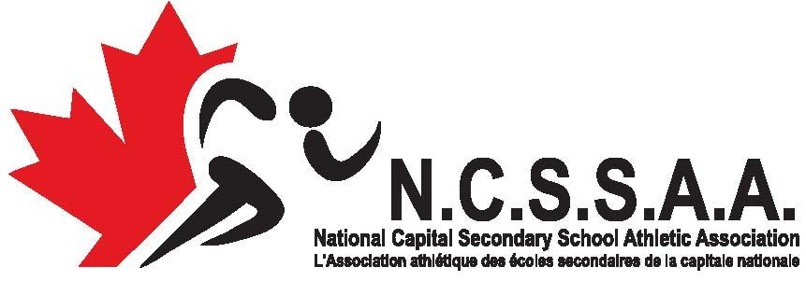

**CROSS COUNTRY RUNNING**

**WEST CONFERENCE CHAMPIONSHIP MEET**

**October 16, 2019**

**LOCATION: WALTER BAKER PARK**

**ARRIVAL:** Please check in at registration table and pick up team information package.

**SCHEDULE:** 9:30 **Coaches Meeting**

10:00 **Midget Girls 4 km**

10:30 **Midget Boys 4 km**

11:00 **Junior Girls 5 km**

11:40 **Junior Boys 5 km**

12:20 **Senior Girls 6 km**

1:00 **Senior Boys 6 km**

2:00 **Awards/Medals (right after SB's)**

**SCORING:** Team scores will be based on the top 4 times. In the event of a tie, it shall be resolved in favor of the team whose fourth runner finishes nearer first place.

**MEDICAL:** First Aid will be on site. It is recommended that each school have a team first aid kit.

**AWARDS:** Medals to the top 3 individuals in each race. Ribbons for 4th to 10th place finishers in each race. Trophies to 1st place team in each category, plus Girls’ Aggregate, Boys’ Aggregate and Grand Aggregate.

**COURSE:** Hilly terrain, trail running. Maps included in team package on race day and available at [www.nchighschoolxc.blogspot.com](http://www.nchighschoolxc.blogspot.com) (follow link to Glebe XC page).

**UNIFORMS:** All competitors must wear appropriate school tops during their races.

No club wear is permitted on the site at any time.

**MARSHALLS:** It is the responsibility of the runner to know his/her course. Marshalls are present for official purposes only and should not be expected to be giving directions on race day.

**FACILITIES:** Washrooms and change rooms will be available for participants. There are several places in which athletes can purchase food and drink within walking distance.

**MEDICAL:** First Aid will be on site. Each school must have a team first aid kit.

**ENTRIES:** www.trackiereg.ca/NCSSAAWest19

ENTRY DEADLINE:

**\*\* October 10th, 2019 23:59\*\***