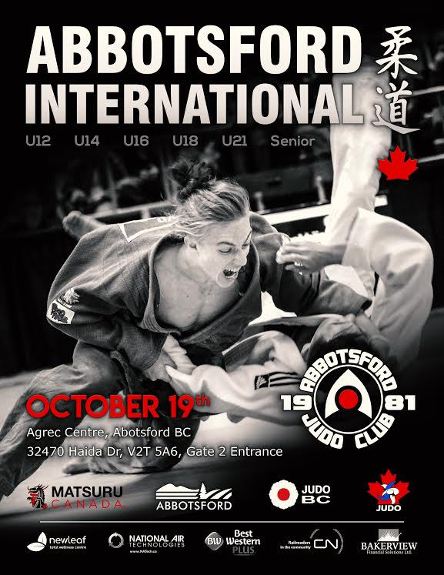

The Abbotsford Judo Club cordially invites all Judoka to participate in the 2019 Abbotsford International for U-12, U-14 Boys and Girls; U-16, U-18, U-21 Men and Women; and Senior Men and Women.
This is a Judo BC sanctioned tournament.
Date: Saturday, October 19, 2019
Location: Ag-Rec Building, Abbotsford Exhibition Park, 32470 Haida Drive, Abbotsford.
Referee Meeting: 7:30 AM All referees & club coaches are encouraged to attend.
Head Referee: Graham Magnusson
Starting Time: 8:00 AM
Weigh-in: All weigh-ins at Tournament location
Friday | Oct 18, 2019 | 5:00 – 8:00 PM | Open Weigh-in
Entry Fee: $50.00 registration fee per competitor for the first division entered;
$25.00 fee per competitor for each additional division.
Each U-14, U-16, U-18, U-21 competitor may enter two age categories.
All entries must be received by Tuesday, Oct 15, 2019; otherwise an additional
$15.00 late fee will apply.
Please register online via Trackie. Clubs wanting to pay for their athletes by Cheque can make cheques payable to the Abbotsford Judo Club.
There will be a $10.00 fee applied to all contestants whose weight does not fall within their registered weight category.
All Competitors must weigh in, regardless of age group.

Eligibility: All contestants in this tournament must be members in good standing with Judo Canada.
All contestants must be of a minimum rank of Yellow Belt.
All competitors will be required to submit a waiver form.
Uniforms: All competitors must have a white Judogi.
Blue Judogi are required for U16 & up.
Elimination: Modified Double Elimination for eight or more competitors
Two pool system for six and seven competitors, Round Robin for five or less.
Rules: The 2019 Abbotsford International will be governed by current:
- IJF Refereeing Rules
- Judo Canada Sanctioning Policy and Tournament Standards
- Judo BC Tournament Standards and Summary
(Should a conflict arise, the decision of the member(s) of the Judo BC Referee Committee in attendance shall prevail.)
Exceptions:
- Minimum rest period shall be 5 minutes instead of 10 minutes
- Old medical rules shall apply for all divisions except U-21 and
Senior Men/Women (on-mat medical assessment is not restricted to head/neck/spinal cord injuries)

 | Novice-Jr & Sr | U-16 | U-18 | U-21 | Senior
Shime-waza | NO | YES | YES | YES | YES
Kansetsu-waza | NO | NO | YES | YES | YES

Enquiries: All phone enquiries may be directed to:
Tokue Suda at: 604-852-8014
E-mail: info@abbotsfordjudo.com

Road Directions from Trans-Canada Highway #1 to Tournament Site

Ag-Rec Building, Abbotsford Exhibition Park, 32470 Haida Drive, Abbotsford

Take Exit 87 (Clearbrook Road) off Hwy #1
- To head north on Clearbrook Road:
  - Turn right if coming from the West (Vancouver)
  - Turn left if coming from the East
- Turn right at Maclure Road
- Turn left at Trethewey Road (becomes Haida Drive)
- Enter Ag-Rec parking lot to the right off Haida Drive

Host Hotel:
Best Western Regency
32110 Marshall Road
Abbotsford, BC V2T 1A1
Phone: 604-853-3111
Fax: 604-852-1750
Toll Free Reservations: 1-800-771-3077
E-mail: sales@bwregency.bc.ca

Alternate Accommodations:

Abbotsford Hotel
2073 Clearbrook Rd
Abbotsford, BC
V2T 2X1
Tel: 604 859 6211

Sandman Hotel & Suites Abbotsford
32720 Simon Ave,
Abbotsford, BC V2T0B8
604-556-7263

