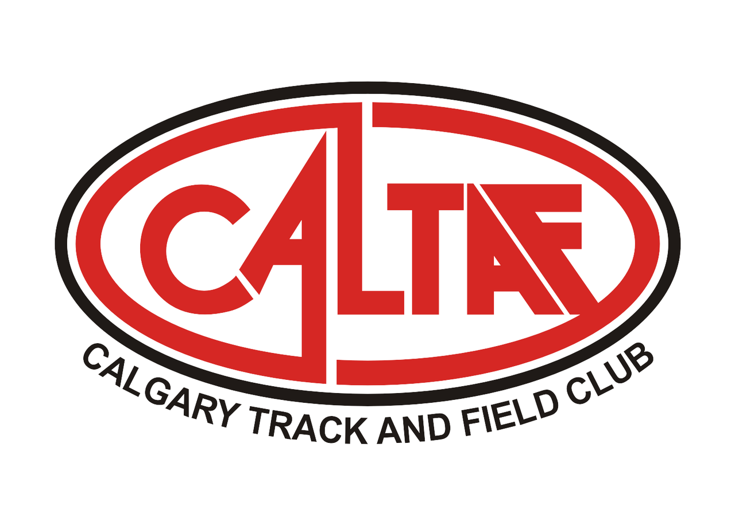
CALTAF welcomes you to the 3rd Annual Festival of 8’s and 4x800m Relay

To celebrate Alberta’s 114th Birthday, a special 190.5m race for athletes 12 and under will be held before the 4x800m Relay

Thursday, August 1st
7:00-8:30 p.m.

Sanctioned by: Athletics Alberta

Website: www.caltaf.com

Questions: Sam Read sam.trackandfieldcoach@gmail.com (403) 690-4212

Venue: Foothills Track - 2431 Crowchild Trail N.W. Calgary, AB

Divisions: U10, U12, U14, U16, U18, Open, Masters, Wheelchair

Entry Fee: 800m $18
4x800m $28
190.5m Free

Entry Procedure:

https://www.trackie.com/online-registration/register/festival-of-8s-2019/34639/

Entry Deadline: Sunday, July 28th at 9:00 p.m.

Late Entries: Will be accepted at the Meet Director’s discretion. Accepted late entries will be an additional $8

Awards: Gift Cards to the Fastest Male and Female U14 and under, U18 and under, U20 and above in the 800m

8 Alberta Birthday Race Medals awarded; A Gold and Silver Medal for Boys and Girls Under 10 and a Gold and Silver Medal for Boys and Girls Under 12. The Gold and Silver Medal Winners shall have their medals presented to them by the Lieutenant Governor of Alberta, Her Honour, Lois Mitchell, in Calgary on September 1st, 2019 on Alberta's 114th Birthday!

