
Provincial Track & Field
Championships



Technical Package 2019

CONTENTS
1.0 WELCOME TO Brampton 2019 3
2.0 CHAMPIONSHIP CONTACTS 3
3.0 ACCOMMODATIONS 4
4.0 TRANSPORTATION 5
4.1 Hotel to Track (Saturday Morning) 5
4.2 Parking 5
5.0 COMPETITION INFORMATION 5
5.1 Competition Venue 5
5.2 Entry Rules 6
5.4 Entry System 7
5.5 Schedule 7
5.6 Equipment 7
5.7 Bib Numbers 8
6.0 COMPETITION PROCEDURES 8
6.1 Warm-up 8
6.2 Event Check in 8
6.3 Protests and Appeals 8
6.4 Spike Length 10
6.4 Track Access 10
7.0 MEDICAL SERVICES 10
8.0 TEAM Ontario Selection Criteria 10
APPENDIX A: VENUE MAP 12
APPENDIX B: EVENTS 13
APPENDIX C: APPEAL FORM 17

WELCOME TO Brampton 2019
On behalf of the Royal Canadian Legion Ontario Command, welcome to Brampton, Ontario, and to the 2019 Royal Canadian Legion Ontario Command Track and Field Championships.
The 2019 Royal Canadian Legion Ontario Command Track and Field Championships (Provincial Championships) are hosted by the District B, Zone B7, Branch 609 and Brampton Track & Field Club. The Championships will take place at the Terry Fox Track & Field Stadium, 9050 Bramalea Rd, Brampton.

CHAMPIONSHIP CONTACTS

Track & Field Chair – Entries  John Crook  The Royal Canadian Legion Ontario Command  rclonttf@gmail.com  416-629-9579 | Assistant Executive Director  Juanita Kemp  The Royal Canadian Legion Ontario Command  jkemp@on.legion.ca  905-841-7999
Local District Chairman  Kiryn Crook  Track.dist.b@gmail.com | Technical Advisor  Larry Mayhew  larrymayhue@rogers.com
Meet Directors:  Frank Bucca  fjbucca@rogers.com  John McCart  Legiontrack@rogers.com | Meet Secretary  Alan Baigent  alanbaigent@sympatico.ca  416-428-7898
Registration:  TrackieReg.com/2019rclontchamps | Officials Co-Ordinator::  Gumarathas Balasubramaniam gumarathas@gmail.com

3.0 ACCOMMODATIONS
When booking hotels, please mention the Royal Canadian Legion Provincial Track & Field Championships.
A SPECIAL rate and a block of rooms have been reserved in each of the hotels listed below. Please see the date at which the rooms will no longer be reserved for the Championships. Reserve early to ensure availability. To be able to get the special rate, you must reserve by phone and not online.
 | Marriott Courtyard – HOST HOTEL (Legion & Officials only 30 rooms)  90 Biscayne Crescent, Brampton,  1-(905) 455-9000  $159.00/night + tax (includes breakfasts)  The hotel will hold the block of rooms until June 12th
 | Comfort Inn (30 Rooms)  5 Rutherford Rd. S. Brampton, ON, CA, L6W 3J3  1-(905) 452-0600  $135.00/night + tax (includes breakfast)  The hotel will hold the block of rooms until June 12th
 | Days Inn (16 Rooms)  260 Queen St E, Brampton, ON L6V 1B9  1-(905) 457-8880  $130.00/night + tax (includes Breakfast)  The hotel will hold the block of rooms until June 12th
 | Fairfield Inn (30 Rooms)  150 Westcreek Blvd. Brampton, Ontario L6T5VJ  1-905.874.7177 Ext 2515  $139.00/night + tax (includes Breakfast)  The hotel will hold the block of rooms until June 12th
 | Quality Inn (40 Rooms)  30, Clark Blvd., Brampton. ON L6W 1X3  1-888-234-4040  $125.00/night + tax (includes Breakfast)  The hotel will hold the block of rooms until June 12th

4.0 TRANSPORTATION

4.1 Hotel to Track (Saturday Morning)
Districts will be responsible for their own transportation from the hotel to the track on Saturday morning. City of Brampton have contacted the districts requesting Transport with the prices..

4.2 Parking
There is a parking lot located adjacent to the Sportsplex complex that will be available during the Championships. There is no charge to park at the stadium.
VIP and Legion Guests will be provided parking behind the Main Stadium a Parking pass will be provided.
Bus Parking Pick up and drop of will be in the Ski Chalet Parking lot see attached map

5.0 COMPETITION INFORMATION

5.1 Competition Venue
The Championships will take place at the Terry Fox Sports Complex. There will be bleacher seating for approximately 1,000 spectators.
Key Facts:
- Lanes – 8 straight corridors and 8 around
- Surface – Polytan
- LJ/TJ runways – Polytan
- PV runways – Polytan
- SP circles – Concrete
- DT/HT circle and cage – Concrete
- JT runways – Polytan
- Spike lengths – 5mm for all events except for Javelin and HJ, where 9 mm will be permitted.

A map of the venue can be found at Appendix A.

During the competition all warm up activities will take place on the Centre Field Grass arear or surrounding grass area around the complex. Hurdle warmups will be allowed on the track prior to start of the session.
On Friday, 12 July, the track and field event sites will be open for practice from 1:00 pm until Meet start at 3pm.
District Chairs are reminded that tents may only be placed or removed in designated areas and with the approval of the Legion/Track management team.

5.2 Entry Rules
5.2.1 Entry Qualification Process
The following Entry Procedures to the Ontario Provincial Championships will apply to athletes who meet the set criteria.

- Midget Boys & Girls - 15 and under as of December 31, 2018 - Born 2004 or later

- Youth Boys & Girls- 17 and under as of December 31, 2018 - Born 2002 or 2003

5.2.2 Eligibility of Entry Performances
Athlete must reside in the District in which they are to represent.
All athletes must complete proper consent forms prior to competing.
Athletes found representing the wrong District will not be included in selection for the Provincial team unless section 5.2.3 has been enacted and approved by all parties prior to registration.
As per the District Criteria for selecting their Team all Athlete performances will be pulled directly from their District meet results
No further changes to performances will be allowed after the entry deadline.
5.2.3 Athletes unable to attend Home District event
If an athlete is unable to attend their home District meet and has a valid reason, the home District Chair should contact another District who’s meet is available and both agree to the inclusion at that meet. Chairs should also agree to the outcome in the event the athlete could be considered to move on for selection into a District team. This decision should be documented and passed on to Provincial Chair for awareness.
This should be completed before either event has taken place.

5.2.4 Decathlon Eligibility
Because the Ontario Command Championships are conducted over 1½ days it has been deemed too short a time period to conduct a safe competitive Decathlon.
To be considered for selection to compete in the Decathlon at Nationals, Youth Boys must provide PV and Discuss verifiable results of other meets from the current outdoor season through their District Chair and passed onto the Provincial Chairman and submitted by the registration deadline. Only 1st & 2nd place will be eligible for progression.
These results points will be added to the results from the Octathlon to determine an over all point tally for the Decathlon this will then be used as per the selection Criteria below.

5.4 Entry System
Registration will open on Monday, June 17th , 2019 at TrackieReg.com/2019rclontchamps. The FINAL entry deadline is Tuesday, July 9, 2019 (12pm ET). NO entries will be accepted after this date, no exceptions.

5.4.1 Confirmation of Entry
Entries will be posted on the Royal Canadian Legion’s web site at: TrackieReg.com/2019rclontchamps

5.5 Schedule
The competition schedule will be available online at TrackieReg.com/2019rclontchamps
Please note that changes may occur based on the final number of entries. The final schedule will be available ASAP after finalization.

5.6 Equipment
Athletes are required to provide their own personal implements that meet technical standards and must be checked-in prior to the event.
The equipment and implement weigh-in station is located in the building structure at the east end of the track. Implements must be checked in no later than three (3) hours prior to the start of the event
Pole vaulters must use their personal poles.

5.7 Bib Numbers
Each athlete will receive one bibs with a number. All athletes must wear the number bib on their chest, except in all jumping events where the bib may be worn either on the chest or back.
Bib numbers will be distributed during the registration process. With the District Chairs.

6.0 COMPETITION PROCEDURES

6.1 Warm-up
During the competition all warm up activities will take place on the Centre Field Grass area or the surrounding grassed areas around the complex. Hurdle warmups will be allowed on the track prior to start of the session.

6.2 Event Check in
Check in will take place in the Start point for their event. All athletes much check in and are asked to report at the following times before the scheduled start or when called:
EVENT | Check-in Time (MINUTES)
Track Events | 30
High Jump | 60
Pole Vault | 60
Other Field Events | 50

6.3 Protests and Appeals
Protests concerning the result or conduct of an event shall be made within 30 minutes of the official posting of the results of the event in accordance with the procedures listed below.
Officials Results Posting Board between the bleachers at the track.

Procedures:
- A protest shall be identified to the Competition (Meet) Director, or designate, at the Technical Information Centre or wherever this person can be found within 30 minutes of the time of the posted results. (NOTE: there will always be someone at the Technical Information Centre who is able to locate the Competition Director or designate.)

- The Competition Director, or designate, will explain the process to the athlete/coach/interested person and provide a Provincial Championships Protest Form.

- The Competition Director, or designate, will take the athlete/coach/interested person to meet with the appropriate Referee (the one who made the decision).

- If the Referee agrees with the protest, the results sheet will be adjusted, and results reposted. (NOTE: this provides a 30-minute opportunity for other athletes or interested persons to appeal this decision from the time of posting of the revised result.)

- If the Referee denies the protest, the athlete/coach/interested person can appeal the decision to the Jury by completing the Provincial Championships Protest Form (Appendix C) which will be taken to the Jury.

- Upon completion of the Provincial Championships Protest Form (NOTE: the Competition Director, or designate, accompanies the protest group and advises them of this option and accepts the completed form and protest fee - $20), the Competition Director, or designate, will make a copy of the completed Provincial Championships Protest Form and will take one copy to the Jury who will then adjudicate upon the issue by reviewing any and all available relevant information.

- The Jury will then prepare their response, including all relevant information, on the Provincial Championships Protest Form and will return the form to the Competition Director, or designate, who will advise both the protest group and Meet Secretary or Results Manager of the results of the protest.

- The Jury of Appeal will remain at the competition site for at least 30 minutes after completion of the final event or until the Competition Director or designate advises them that no further protests have been received and they may leave.

6.4 Spike Length
5mm spikes are the maximum length allowed except for High Jump and Javelin which allows for 9mm spikes. Xmas Tree and Needle spikes are not allowed.

6.4 Track Access
Access to the track will be restricted to Athletes, Officials, volunteers and Legion Members and Chaperones

7.0 MEDICAL SERVICES
A First Aid team will provide the necessary healthcare for the participants of these Provincial Championships.
For non-urgent cases athletes will be directed to the nearest clinic/Hospital. Transportation is the responsibility of the District/athlete. Please note there may be a private fee charged by any of the walk-in clinics. For urgent cases, athletes will be taken by ambulance to the nearest hospital.
NOTE: Athletes must be accompanied by a coach or chaperone for any medical treatments.

8.0 TEAM ONTARIO SELECTION CRITERIA
Team Ontario will consist of a max 40 athletes with a restriction of no more than 25 in a single age category. The following is the criteria in which the team is selected.
All winners of events will become members of the selection pool. This pool normally has 45 to 50 athletes.
The following is the order of selection to the Legion National Youth Track & Field Championships:
- First Place Athletes - double & triple winners.
- All remaining athletes in the selection pool will have all of their performances compared to the Legion National Results for the past 5 years. Athletes will be ranked based on this comparison.
- Athletes wishing to compete in Decathlon must indicate to the Provincial Track & Field Chairman their intention to compete at Nationals before the Provincial Championship commence, through their District Chairman prior to registration deadline. They must provide verifiable PV and Discus Results from the current year to be considered.
Selection examples
Example: Jane Smith wins the 200m 15 and under in 25.78 sec.
Over the last 5 years this would have placed 2nd. 4th, 4th, 2nd, 1st = 2+4+4+2+1= 13 pts.
Paul brown wins the 1500m 17 and under in 4:02.15 min.
Over the last 5 years this would have placed 5th, 4th, 6th, 3rd, 3rd = 5+4+6+3+3= 21 pts. Therefore, Jane with the lower point total will be selected before Paul
The Provincial Track and Field Committee may look at the second-place finishers. These 2nd place finishers will be ranked with the 1st place finishers using the same criteria.
Note: Updated 5-year comparison lists (Provincial and National) will be prepared and be available to District Chairs by the January Teleconference call.
Team Staff will review the results of the meet and the athlete’s other performances when entering them into events at the National meet. Athletes may be entered into events other than those which they won at the Provincial meet.

APPENDIX A: VENUE MAPS
Please note that the venue map displays the locations of the track, and available buildings the track layout has been modified since this photo was taken.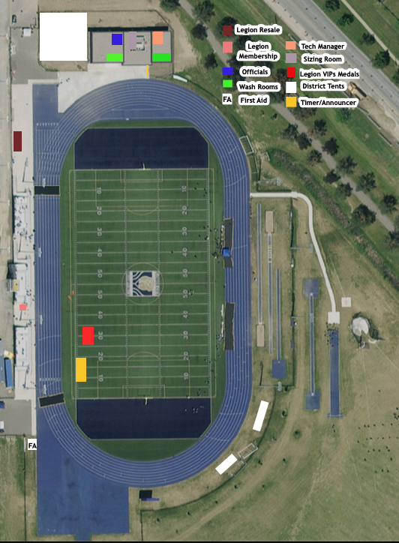

Bus & VIP Parking

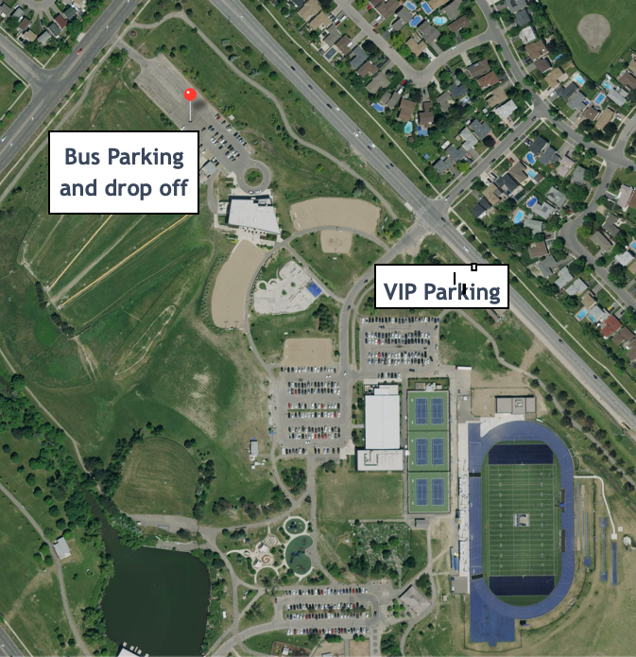

APPENDIX B: EVENTS

Track Events
EVENTS | MIDGET BOYS | MIDGET GIRLS | YOUTH BOYS | YOUTH GIRLS
100m | YES | YES | YES | YES
200m | YES | YES | YES | YES
300m | YES | YES
  NO | N
  NO | NO
400m | NO | NO | YES | YES
800m | YES | YES | YES | YES
1200m | YES | YES | NO | NO
1500m | NO | NO | YES | YES
2000m | YES | YES | NO | NO
3000m | NO | NO | YES | YES
80m Hurdles | NO | YES | NO | NO
100m Hurdles | YES | NO | NO | YES
110m Hurdles | NO | NO | YES | NO
200m Hurdles | YES | YES | NO | NO
400m Hurdles | NO | NO | YES | YES
1500m S/C * | YES | YES | NO | NO
2000m S/C | NO | NO | YES | YES
Walks | 1500m | 1500m | 3000m | 3000m
*No water jump

Hurdle Specifications
80mH - Midget Female 12m to H1; 8m between / Height = 30" / 76cm
100mH – Youth Female 13m to H1; 8m50 between / Height = 30" / 76cm
100mH – Midget Male 13m to H1, 8m50 between / Height = 33" / 84cm
110mH – Youth Male 13m72 to H1; 9m14 between / Height = 36" / 91cm
200mH – Midget Female Start @ 200m lines & use 400mH markings/Height = 30"/ 76cm, 15m to H1
200mH – Midget Male Start @ 200m lines & use 400mH markings / Height = 30" / 76cm, 15m to H1
400mH – Youth Female Start @ 400m lines; 50m to H1 then use 400mH markings / Ht = 30" / 76cm
400mH – Youth Male Start @ 400m lines; 50m to H1 then use 400mH markings / Ht = 33" / 84cm

Field Events
EVENTS | MIDGET BOYS | MIDGET GIRLS | YOUTH BOYS | YOUTH GIRLS
High Jump | YES | YES | YES | YES
Pole Vault | YES | YES | YES | YES
Long Jump | YES | YES | YES | YES
Triple Jump | YES | YES | YES | YES
Shot Put | 4 Kg | 3 Kg | 5 Kg | 3 Kg
Discus | 1 Kg | 1 Kg | 1.5 Kg | 1 Kg
Javelin | 600 gm | 500 gm | 700 gm | 500 gm
Hammer | 4 Kg | 3 Kg | 5 Kg | 3 Kg

Multiple Events
Midget F Pentathlon | 80mH, 800m, Long Jump, High Jump, Shot Put
Midget M Pentathlon | 100mH, 1000m, Long Jump, High Jump, Shot Put
Youth F Heptathlon | 100mH, 200m, 800m, Long Jump, High Jump, Shot Put, Javelin
Youth M Octathlon | 110mH, 100m, 400m, 1500m, Long Jump, High Jump, Shot Put, Javelin

Decathlon
To be considered for selection to compete in the Decathlon at Nationals, Youth Boys must provide PV and Discuss verifiable results of other meets from the current outdoor season through their District Chair and passed onto the Provincial Chairman and submitted by the registration deadline. Only 1st & 2nd place will be eligible for progression.

Intentional Blank Page

APPENDIX C: APPEAL FORM

In accordance with IAAF Rule 146,

Appeal lodged on behalf of/appel déposé au nom de:
Name/nom: _____________________________ District: _________________________________________________
Competition no./nom: ______________ Event/Épreuve: _____________________________________________
Appeal lodged by (name)/Appel déposé par (nom): _____________________________________________
IAAF Rule(s) alleged to have been contravened /Règlement(s) de I’IAAF qui aurai(en)t été enfreint(s):________________________________________________________________________________________
___________________________________________________________________________________________________
Grounds for lodging appeal / Raisons de cet appel:
___________________________________________________________________________________________________
___________________________________________________________________________________________________
___________________________________________________________________________________________________
___________________________________________________________________________________________________

Signature: ___________________________ Date: _____________________________________

OFFICIAL USE ONLY / USAGE OFFICIEL SEULEMENT

Time at which result was announced____________________
Time at which oral protest was made___________________
Time at which referee dismissed protest________________
Time of receipt of written appeal________________________

Jury’s decision: Appeal Upheld_____________ Appeal Denied_____________

______________________________________________________________________________________________________
______________________________________________________________________________________________________
______________________________________________________________________________________________________
Jury Chairman_________________________ Jury_________________________________________________________

Secretary_____________________________ Date__________________Time__________________________________

Meeting Manager / Appellant notified: Date__________________Time________________________________

Jury Construct
The jury will consist of 3 of the 4 following roles:
Meet Director (Chairman)
Technical Manager
Field Referee
Track Referee

