Pugwash Harbourfest and Homecoming
Salt Dash 5km Fun Run

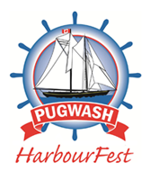

When: Saturday, July 27 – 9:00am start
Where: Race kit pick-up located beside Eaton Stage (Water Street)
Come for the race, stay for the Festival! The 5km Salt Dash is a fun run in conjunction with the Pugwash Harbourfest and Homecoming Festival. This event offers a 5km run consisting of an out and back course. Walkers are also welcome in this event!
Registration Fee: $25 – Register Online @ https://www.trackie.com/online-registration/register/pugwash-harbourfest-5km-salt-dash/34361/
The Race Kit Includes:
- Dry Fit Running T-shirt (register by July 13 to secure your size)
- Race Bib
- Finishers Medal
Race Kit Pick-Up: 7:30-8:45am on July 27 as the event will start at 9am sharp.

**Please note that this year’s event is a “Fun-run” which is not sanctioned. This is in keeping with the Harbourfest and Homecoming mandate of promoting fun and fitness in our community.**

