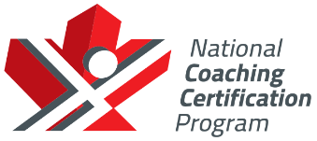
NCCP SPORT COACH COURSE
(TRACK & FIELD)

Date: Friday July 5th, 6th and 7^{th 2019}

Time: Friday (6:00-9:15) Saturday (8:30-5:30) Sunday 8:30-4:30).

Location: Ray Lewis Track & Field Centre (Mohawk Sports Park) 1100 Mohawk Road East, Hamilton, (Upper Kenilworth Avenue & Mohawk Road East).

Cost: $150.00 (AO Members) $200.00 (Non AO Members).

Registration:

Contact: Kevin Gonci kgonci4@gmail.com (905) 317-9381.

Hosted by: Hamilton Elite Athletic Team & Golden Horseshoe Track & Field Council.

Overview : The NCCP Sport Coach Course teaches the basic skills of all events in track and field. It is ideal for the generalist coach that may be coaching introductory-intermediate level athletes in a multiple events, often in a school or club, at a junior high or high school level. This course will start you on your way to becoming a Certified Athletics Competition Introduction Coach with the National Coaching Certification Program (NCCP).

Schedule:
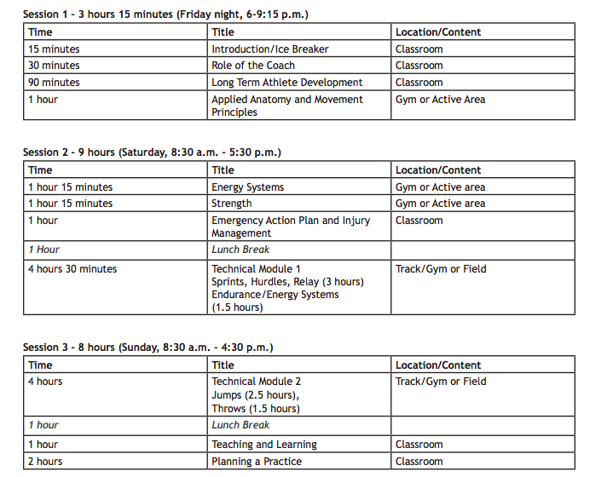
HOSTED BY

