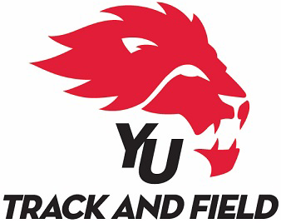
18th Annual York University Xmas Open
Track & Field Meet
Saturday, December 1ST, 2018

Tentative Schedule of Events (final schedule available on day of the meet)

Track Events
1:00pm 600m Women
600m Men
1:15 1500m Women
1500m Men
1:30 60m Hurdle Heats Youth Girls / Senior Women
60m Hurdle Heats Youth Boys / Junior Men / Senior Men
1:40 60m Heats Women (Top 8 Times to A Final, Next 8 Times to B Final)
60m Heats Men (Top 8 Times to A Final, Next 8 Times to B Final)
2:10 60m Hurdle FINAL Youth Girls / Senior Women
60m Hurdle FINAL Youth Boys / Junior Men / Senior Men
2:20 60m Final (A& B) Women
60m Final (A& B) Men
2:30 1000m Women
1000m Men
2:50 300m Women
300m Men
3:50 3000m Women
3000m Men
4:25 4x200m Women then Men
4x800m Women then Men
4:35
4x400m Women then Men

ALL TIMED SECTIONS WILL BE RUN FROM SLOW TO FAST
EVENTS WILL RUN AHEAD OF SCHEDULE WHENEVER POSSIBLE BY NO MORE THAN 30 MINUTES

Field Events:
1:00pm Men’s Long Jump Men’s High Jump Men’s Shot Put Women’s Pole Vault
2:30pm Men’s Pole Vault
3:00pm Women’s Long Jump Women’s High Jump Women’s Shot Put
TBD: Men’s and Women’s Weight Throw will be conducted at the end of the day once all other events have completed
Weight Throw – Men followed by women beginning
30 minutes after the last event in the field house.

Implement Weight-in will be conducted at the throwing circle – 1 hour prior to the event.

