2018 Judo Saskatchewan Winter Camp
Watrous Civic Centre
404 Main St, Watrous, SK S0K 4T0
December 21, 22 & 23, 2018
Arrival time: Friday 5:30 - 6:00 PM
Pick up time: Sunday 12:30

Cost: $100 before December 10, 2018
$120 December 10 - December 18, 2018

Born in 2010 or earlier
Member of Provincial Judo Association
Must have slept overnight away from their parents.

Registration online with trackie

Guest Coach Warren Seib
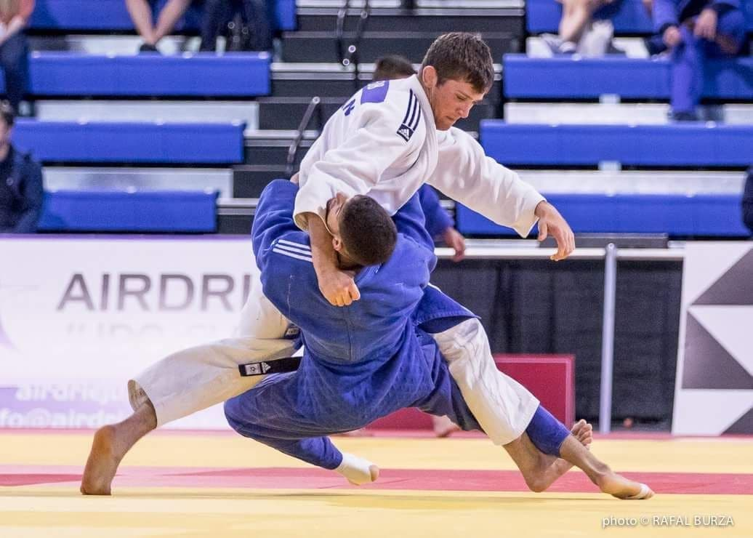
Important Things to Bring: Judo Gi’s Sleeping Bag & Pillow, Toiletries, Gym Clothes & Runners, Night clothing, change of clothing, Winter Clothing, Water bottle, Spending Money.

