PHOENIX ATHLETIC
800M / Long Jump Night - Thursday June 28th, 2018
Birchmount Stadium 75 Birchmount Rd, Scarborough, ON M1N 3J7

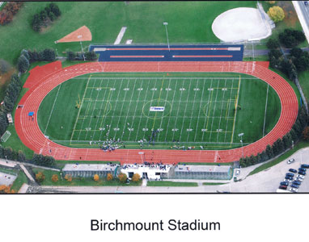
6:00 pm Start time - Timed finals Slow to fast with the two fastest Women’s sections and Men’s
sections going last.
Event #1 Women’s 800m
Event # 2 Men’s 800m
Event # 3 Men’s Long Jump 6:00 pm
Event # 4 Women’s Long Jump 7:30 pm
Entry Deadline: Tuesday June 26, 2018 at 6:00 pm. (Through Trackiereg)
Entry Fee: $15.00 per event before Tuesday June 26th, 2018 – Post entry $20.00 – payable to Phoenix Athletics
Registration and clerking: The south end of the Stadium.
Seed Times: Event Seed times must been run in the last 18 months indoors or
Outdoors.
Awards: 800 m night t-shirt for the winner of each heat. Monetary awards will be give to the top-four finishers in the women’s and men’s 800m, with $25 for fourth place, $50 for third place, $75 for second place and $100 for first.
Meet Director Bill Stephens – bill.stephens@bell.net

Entries Chair: Alan Baigent – alanbaigent@sympatico.ca

