



2018 Kamloops Throws Twilight Meet
Hosted by the Kamloops Track and Field Club
Sanctioned by BC Athletics

Wednesday, July 11, 2018

Location:
Tournament Capital Centre, 910 McGill Rd., Kamloops, BC (See page 3 for driving directions).

Facility:
Polyurethane surface for Javelin, and concrete circles for Hammer. Change rooms available. Concession available at TCC

Meet Director:
Dylan Armstrong: Phone: (250) 299-1666
Email: armstrong1dylan@gmail.com

Meet Manager:
Judy Armstrong: Phone: (250) 377-3378
Email: judy54armstrong@gmail.com

Eligible Athletes:
- 2018 BC Athletics Annual Athlete members or equivalent from another Prov/Terr, or National Athletics Federation.
- 2018 School Club Members – Elementary, middle or high school students whose schools hold a BC Athletics School Club Membership are eligible to compete.

Entry Fees:
- $15.00/event submitted electronically using Hy-Tek Team Manager or online at TrackieReg (preferred method).
- Late entries will be charged $30.00/event.

Registration & Entries:
When filling in their registration, Master’s athletes are requested to provide their age as of the first day of the meet – July 11, 2018. For all other athletes, the age is calculated as of the end of 2018.

Entries Chairperson: Wayne Elke
Email: wcelke@shaw.ca
All entries must be submitted to Wayne by the following methods:
- TrackieREG – Register online and payment may be made using a credit card – Kamloops Throws Twilight Meet ( )

**ENTRY DEADLINE**: 11:59 pm, Sunday, July 8, 2018. All entries must be received by this date to avoid late entry fees. The late entry deadline is 7:00 pm, Tuesday, July 10, 2018. After this date, any further entries will only be accepted at the meet and only if there is room in the event.
COMPETITION RULES AND OTHER INFORMATION

COMPETITION CATEGORIES - 2018:
13 Year Olds (05), Midget (03/04), Youth (01/02), Junior (99/00), Senior (84-98), Master (1983 and earlier - 35yrs of age+).

AWARDS:
Where will be no medals or ribbons awarded for this meet.

MARSHALLING:
Check-in for all field events is at the event site. All athletes must check-in a minimum of 30 minutes prior to the scheduled start time.

COMPETITOR'S NUMBERS:
Competition numbers must be worn on the front or back for field events (at the discretion of the official).

IMPLEMENTS:
All implements will be supplied by the meet organizers. Athletes may use their own implements which must meet IAAF standards. They must be weighed-in and measured at least 30 minutes prior to the competition. The weigh-in station will be located in the Throws shed near the throws area.

SPIKE LENGTH:
The maximum spike length allowed is 9mm for Javelin.

ORDER OF EVENTS:
All age groups and genders will compete together starting with the hammer and then javelin. Events may start up to 30 minutes earlier than the scheduled time.

ATHLETES WITH CONFLICTING EVENTS:
Athletes must notify the officials at all events which are in conflict. Athletes in field events will forego their attempt in a round if the round has been completed before they return.

COMPETITIVE ATTIRE:
All athletes are encouraged to wear their club uniform.

PROTESTS
After discussion with the event referee, any further protest must be submitted in writing to the Chief of Officials and the Jury of Appeal within 30 minutes of the posting of the results of the event concerned. A $25.00 protest fee is to accompany all protests. If the protest is upheld then the protest fee will be returned.

JURY OF APPEAL:
A jury of appeal consisting of three competent and qualified persons will be available for decisions arising from protests. All Jury of Appeal decisions are final.

MEDICAL:
BC Ambulance Service.

CONCESSION:
There will be a concession available during the meet, near the main entrance to the Tournament Capital Centre.

Driving Direction to the Tournament Capital Centre:

Arriving from the west (Highway #5): Exit to the right at exit 367 and turn left onto Hillside Way (this will take you across the highway). When you reach the end of Hillside Way turn right onto Hillside Drive and follow this road to the Tournament Capital Centre. (NOTE: left turns are not permitted on McGill to the TCC parking. Please continue through the light at Hillside Drive and follow University Drive. Then make your way through the parking area for Hillside Stadium.)

Arriving from the east (Highway #1): Exit to the right at exit 370 and turn right onto Summit Drive. Follow Summit Dr. and turn left after the Real Canadian Superstore onto McGill Rd. Follow McGill until you reach the Tournament Capital Centre.

Tournament Capital Centre
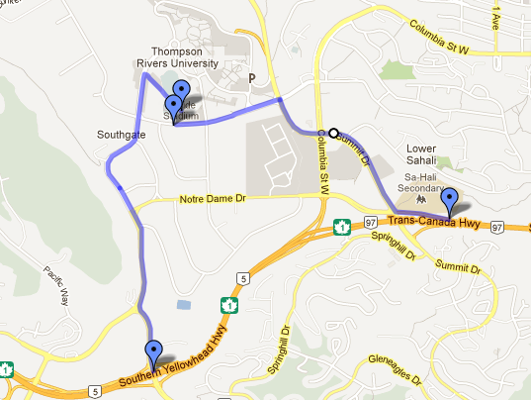
Exit 367 from the west.
Exit 370 from the east.

