St. Albert Challenge
May 25-27, 2018
Fowler Athletic Park:
61 Sir Winston Churchill Avenue
St. Albert, Alberta
Sanctioned by Athletics Alberta

Location and Facility

Fowler Athletic Park: 61 Sir Winston Churchill Avenue, St. Albert, Alberta
- 8 lane 400m track, Plexitrac latex all-weather track and runways
- Throwing Circles: concrete/wood circles, aluminum cantilevered throwing cage with nylon netting
- Photo Timing System: FinishLynx, Hy-Tek results, and wind gauges
- Food truck or Food Service: available Saturday and Sunday
- Washroom facilities available

Meet Enquiries

Meet Directors: Amy Millar / Joanna Cooper
Meet Managers: Janice Curle
If you have any questions or inquiries about the meet, please email stalbertchallenge@gmail.com and the appropriate member will be happy to help.

Meet Hotel

- St Albert Inn & Suites: St. Albert Trail, St. Albert
- Best Western Plus – The Inn at St. Albert: St. Albert
- Best Western - West Wood: 18035-Stony Plain Road, Edmonton
- Days Inn & Suites: 10010 179 Street, Edmonton
*All Edmonton Hotels are just off the Anthony Henday.

Registration Package

Registration packages will be available for pick-up at the Registration Desk located at the start line by 1 hour before the start of the meet. Payment online through Trackie needs to be confirmed before package will be released.

Eligibility

- All athletes must be registered members of Athletics Alberta as of the entry deadline, no exceptions.
- Out-of-province athletes must be registered with their respective Provincial Athletics Association.

Age Categories Offered

Age Group is based on age as of December 31, 2018.
Tykes: 9 & Under (born 2009 or later) | Midget (U16): 14 & 15 years (born 2003-2004)
Pee Wee: 10 & 11 years (born 2007-2008) | Youth (U18): 16 & 17 years (2001-2002)
Bantam: 12 & 13 years (2005-2006) | Open: 18+ years (born 1999 or earlier)

Entry Fees

Individual Events | $20
Bantam Multiple Events | $30 per day
Pee Wee Multiple Events | $30 per day
Tykes Multiple Events | $30 per day
Relays | $30 per relay team
Athlete Registration | $5.00
Fees Payable: Online at the TrackieReg website during registration.

Entry Deadline and Process
- Entries must be received by noon (12:00 p.m.) on Tuesday, May 15, 2018.
- Entries submitted after this date (Tuesday, May 15, 2018) will be charged double.
- Registration fully closes Friday, May 18, 2018 at noon (12:00 p.m.).
- Scratch deadline is Friday, May 18, 2018 at noon. Scratches after then will still be charged.
- All entries MUST be done using the TrackieReg web site.
- Meet Schedule will be available on the Trackie Website starting May 1, 2018. A finalized copy will be posted by the end of the day May 24, 2018.

Please send all meet questions to: stalbertchallenge@gmail.com .

Events Offered
Event | Tyke | Pee Wee | Bantam | Midget | U18 | Open
100m |  |  |  | X | X | X
200m |  |  |  | X | X | X
300m |  |  |  | X
400m |  |  |  |  | X | X
800m |  |  |  | X | X | X
1200m |  |  |  | X
1500m |  |  |  |  | X | X
2000m |  |  |  | X
3000m |  |  |  |  | X | X
Steeplechase |  |  |  | 1500m | 200m
Sprint Hurdles |  |  |  | 80m Women  100m Men | 100m Women  110m Men | X
Intermediate Hurdles |  |  |  | 200m | 400m | 400m
High Jump |  |  |  | X | X | X
Long Jump |  |  |  | X | X | X
Triple Jump |  |  |  | X | X | X
Shot Put |  |  |  | 3kg Women  4kg Men | 3kg Women  5kg Men | X*
Discus |  |  |  | 1kg | 1kg Women  1.5kg Men | X*
Javelin |  |  |  | 500g Women  600g Men | 500g Women  700g Men | X
Hammer |  |  |  | 3kg Women  4kg Men | 3kg Women  5kg Men | X*
4 x 100m Relay | X | X | X | X | X | X
Medley Relay | 100-50-50-200 | 200-100-100-400 | 200-100-100-400 | 400-200-200-800 | 400-200-200-800 | 400-200-200-800
Multiple Events | X | X | X

* Age Categories Specification for Masters and according to age groups. Masters age is as of May 25, 2018, and Masters specifications are at http://www.world-masters-athletics.org/rules/appendix.pdf .

Field event age classes may be combined if entry numbers are low; medals will still be awarded separately.

Multiple Events for Tyke, Pee Wee and Bantam -- Specifications and Information

Age Group | Saturday | Sunday
Tyke | 60m, Turbo Javelin, Standing Long Jump | 300m, Shot Put, Long Jump
Pee Wee | 60m, Shot Put, Standing Long Jump | 600m, Turbo Javelin, Long Jump
Bantam | High Jump, 80m, 800m, Discus | 80m Hurdles, 150m, Long Jump, Shot Put
Note: Events may not occur in this order for Tykes, Pee Wee and Bantams.

Overall Top Athletes

Scores will be kept for Multiple Events: 1st place in each event gets 10 points, 2nd 9 points, 3rd 8 points, etc. down to 10th and below who get 1 point. Points from the day’s events will be totalled and medals given to top 3 athletes overall.

Athletes may miss or “scratch” an event and continue the competition.

Modified Rules for Field Events:

Modified Rules for Tykes and Pee Wee Long Jump
Tyke and Pee Wees will have 1 m take-off area and the official will judge the take-off spot accordingly and measure. For the competition, all jumpers will have 3 attempts.
Standing Long Jump: Jump is done with feet together, no steps allowed.

Modified Rules for Bantam High Jump
Three successive failures will eliminate the jumper from further competition. Starting height of 0.90m, increments of 10cm until a height of 1.20m, increments of 5cm thereafter.

Further clarification of the Multiple Events rules as well as instruction on the modified field events will be given on-site.

General Rules

- Marshalling takes place on the Speed Track. Athletes who do not present themselves in the Marshalling area as required will not be eligible to compete in the race. Athletes will remain within the marshalling area until start of race.

- All track event athletes are required to check in at the Marshalling Table at least 20 minutes prior to the scheduled event start time. When checking in, please have your number on and your spikes available to verify spike length.

- Field event athletes will marshal at the event competition area, and are requested to be at the competition area 20 minutes before the scheduled start time of the event.

- The competition numbers must be worn on back for events run entirely in lanes (60m to 400m). Athletes in horizontal jump events must wear number on front; for other field events, athletes may wear numbers either on front or on back. Please ensure that singlets/ uniforms are tucked in so that hip numbers are visible. This ensures photo timing can be done effectively and properly.
  - Numbers must be worn on the front for all track events not finishing in lanes (including the final runners on medley relay teams).
  - For Tykes, Pee Wee and Bantam athletes, competition numbers must be worn on the front for all events.
  - Hip numbers (distance and relay events) must be clearly visible on the athletes’ right side hip.

- All seed times must be accurate; all non-verified seed times will be given a NT (no time). Repeat violations will translate into penalties against coach and club. Athletics Alberta “Rules of Illegitimate Seed Times” will be followed. (Please see www.athleticsalberta.com/hosting-and-sanctioning, especially the details provided on www.athleticsalberta.com/app/uploads/2015/11/AA-seed-performance-policy-Updated-Feb-2015.pdf .) If coaches submit an erroneous seed performance or one that cannot be verified, the athlete will instead have an “NT” (or equivalent for field event).

- Starting blocks are mandatory for all athletes Midgets and up. Starting blocks are optional for Masters. Starting blocks will not be used for Tykes, Pee Wees, nor Bantam events. Medical exemptions (i.e.: to allow the athlete to not use starting blocks) require prior approval from Athletics Alberta’s Technical Manager.

- Throwing implements will be provided. No personal implements will be permitted unless by approval of officials at the event.

- Spikes are to be no longer than 7mm in length. Only smooth “Christmas tree” or pyramid type spikes will be allowed. No pin, needle, or other elements will be permitted. This will be enforced and athletes will be required to remove any non-conforming spikes.

- Scratches during the competition are to be submitted at the registration area, near the 100m start line.

- Athletes competing in heats who do not intend to compete in the final must inform the Results Desk before the heats. Such athletes will be marked as exhibition, thus allowing someone else to advance to the final. Otherwise, IAAF Rule 142.4 will be applied (i.e.: the athlete may be disqualified from participating in the rest of the meet).

- Results will be posted during the meet, and will be available on the www.ellistiming.ca website.

- Restricted access to field for coaches, athletes (with their numbers), officials, and volunteers only. Spectators are not to be present on the infield anywhere.

- Tyke, Pee Wee, and Bantam athletes who miss an event will be allowed to continue in the competition.

- All athletes must wear proper club/school uniform to compete.

- Medals will be awarded to the top three finishers. Ribbon for the top 10 in the Tyke, Pee Wee, and Bantam categories.

- Breaking Record: If you break a provincial record, paperwork must be submitted at the meet so the appropriate individuals and paperwork can be processed in a timely manner. Athletes expecting to break a record and requiring a special form should bring the form to the meet (various factors, like Internet access outages, have been known to prevent the Results team from printing a needed form).

Hurdles and Throws Specifications

Below is from https://www.athleticsalberta.com/officials/ . Masters specifications are at http://www.world-masters-athletics.org/rules/appendix.pdf .
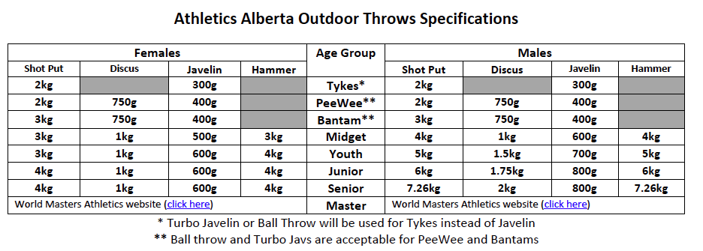

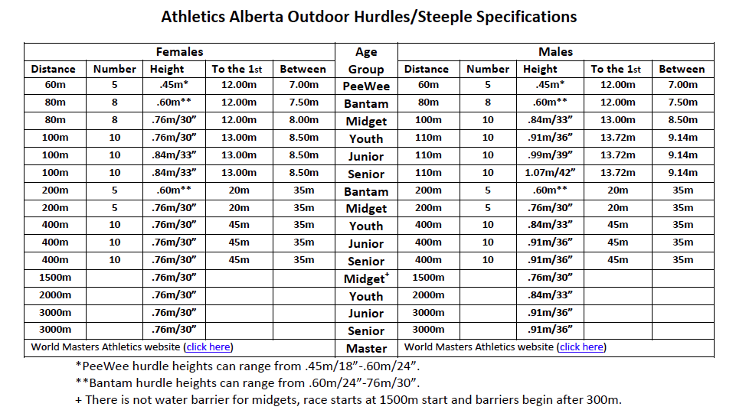

Alberta Summer Games Trial Information

Trials for Zone 7

From July 19th to the 22nd, 2018, over 3,000 athletes, coaches, and officials from across Alberta will be in Grande Prairie to compete, learn, and share experiences of a lifetime at the 2018 Alberta Summer Games.
Athletes ranging in age from 11 to 17 years old representing 14 different sports will befriend teammates and competitors from eight regional zones. Over 2,000 volunteers and 100+ sponsors will pull together to meet a challenge and a common goal: to make the 2018 Alberta Summer Games in Grande Prairie the “Best Ever” Alberta Games.
These Games belong to everyone in the Grande Prairie region and I encourage you to get involved. Join in the excitement and take this opportunity to show with pride our flourishing community, our first class facilities for sport and culture, and Grande Prairie’s genuine hospitality. Take this opportunity to invest in our most precious resource – the youth and future of Alberta.
These Games would not be possible without the individuals, groups, and businesses who donate their time, money, and services. Collectively, they are known as the “Friends of the Games”. I am encouraging you to accept this invitation to become a “Friend of the Games”.
AGE GROUPS

MIDGET: 15 years of age and under as of December 31, 2018 (born in 2003-2004)
YOUTH: 16-17 years of age as of December 31, 2018 (born in 2001-2002)

What do you need to do next?
Step 1: Find where your Zone Trials are happening.
Step 2: Read the Team Eligibility Requirements.
Step 2: Register to participate in your Zone Trials.
Step 3: Pay for your Team Fee.
Step 4: Step one of Declaring for your Zone. (Online Form Only) -- https://form.jotform.com/80814691384968
Step 4a: Step two of Declaring – Create a profile on ASG site.
Step 5: Review the Alberta Summer Games website -- see https://albertasport.ca/alberta-games/summer-games/ .
Step 6: Review the requirements of attending the games on your Zone Team.
Step 7: Review the Parent and Athlete Frequently Asked Questions section at https://albertasport.ca/alberta-games/faq/ .

