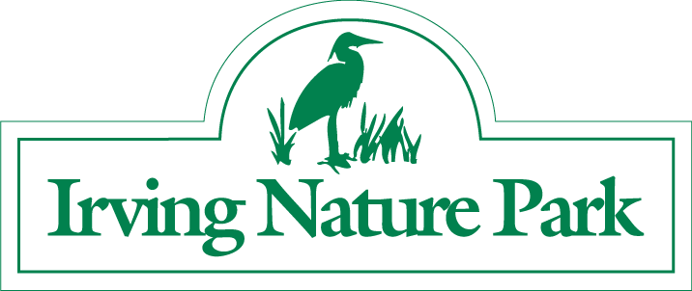
Brent Kelly Memorial Five Mile
Run/Walk
April 21, 2018

Brent Kelly was a young boy who passed away unexpectedly of Giant Cell Myocarditis, a rare heart disease in June of 2004 at the age of 12. After Brent died, we all felt a tragic sense of loss. He was a fun loving youngster with loads of energy and a great sense of humor. We will miss him very much. As his aunt, I wanted to do something to preserve his memory and his spirit and came up with the idea of holding a memorial run/walk in his memory.

As a youngster, Brent loved to hike along the Irving Nature Park with his family and it was always a special place for him. Brent also enjoyed running and competed in cross country and track for his school. It is a natural fit to hold a Memorial Run for Brent at the Irving Nature Park. All proceeds from the run will be donated to the Brent Kelly Memorial fund which is being used to benefit youth in the Saint John Area.
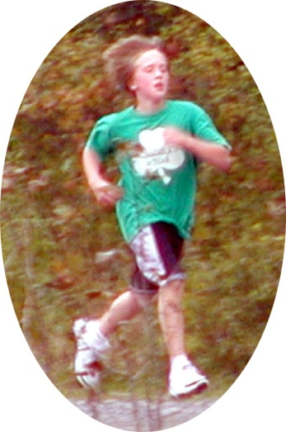

This year marks the 14th year for the Brent Kelly Memorial 5-Mile walk/run. Over the past 12 years, over 3,000 have participated in this event making it one of the largest running events in New Brunswick. Donations from the Brent Kelly Memorial Fund have been in excess of $20,000 and have been made to the Lancaster Minor Basketball Association (LMBA), Beaconsfield Middle School, St. Patrick’s Elementary School, Pro Kids and have also been used to fund awards in Brent’s name for these organizations.

In support of this event, I am looking for sponsors for water, finish line refreshments, draw prizes and race packet items. Anything at all you can assist with would be greatly appreciated. Registration for the event is only $25 with the net proceeds going to Brent's Memorial Fund so I am trying to keep costs to a minimum. Thank you for your support.

Marta Kelly, Brentman's aunt

