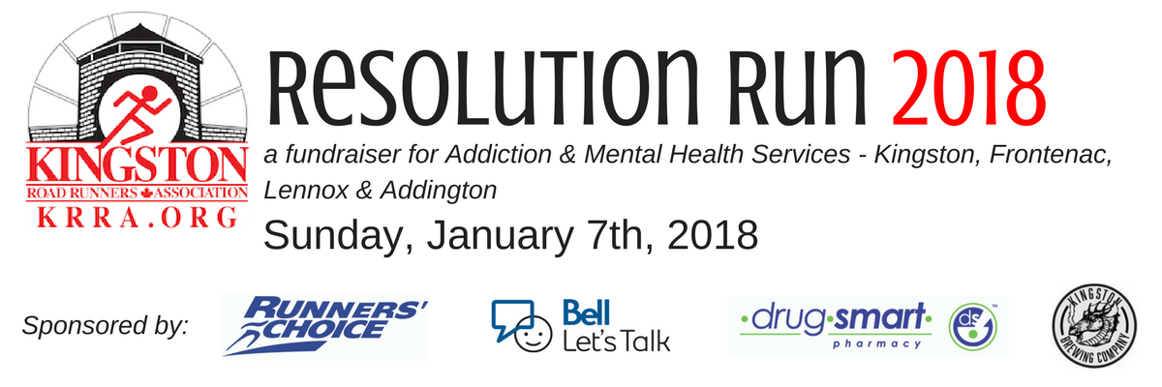
Sunday, January 7th, 2018 | Royal Military College, Kingston
8:30 am Registration + Kit Pickup: Kingston Military Community Sports Centre, 11 Navy Way
9:30 am 1Km Kid’s Indoor Track Run (unitimed)
10:00 am 8 km Road Race (timed) and 2 km Walk (untimed) Starts
11:00 am Awards | Prize Draws | Food

Medals will be awarded to the top 3 runners in KRRA age categories.
Great draw prizes for participants, and post-race food provided by The Kingston Brewing Company.
Free parking and washrooms available

Contact Race Director Robin at resolutionrunkingston@gmail.com for questions or to volunteer

PLEASE COMPLETE THE FOLLOWING FORM FOR EACH PARTICIPANT
RETURN COMPLETED FORMS WITH PAYMENT (CASH OR CHEQUE) TO:
RUNNER’S CHOICE, 56 BROCK STREET KINGSTON
PLEASE MAKE CHEQUES PAYABLE TO: Kingston Road Runners Association (or KRRA)

--------------------------------------------------------------------------------------------------------------------------------------
FIRST NAME ________________________ LAST NAME ________________________
ADDRESS ___________________________________________________________________
PHONE ______________________ EMAIL __________________________________
AGE ON JANUARY 1, 2018: ________ SEX (CIRCLE ONE): M F
RACE ENTERED (CHECK ONE) □ 8 KM Road Race □ 2 KM Walk □ Kid’s Indoor Track Run

ADVANCE ENTRY FEES:
The first 120 registrants will receive a pair of Bell Let’s Talk Mittens!
8k Road Race ADULTS $40 KRRA MEMBERS: $30* STUDENTS: $30* (w/ student ID)
2k Untimed Walk ADULTS $10 CHILDREN: FREE (12 and under)
Indoor Track Race CHILDREN: FREE (12 and under)
*You must register in advance to receive discounted registration fees. Race Day registration is $40 for KRRA Members and Students

PLEASE READ AND SIGN THE PARTICIPATION WAIVER BELOW

I know that running a road race is potentially hazardous activity, which could cause injury or death. I will not enter and participate unless I am medically able and properly trained, and by my signature, I certify that I am medically able to perform this event, and am in good health, and I am properly trained. I agree to abide by any decision of a race official relative to any aspect of my participation in this event, including the right of any official to deny or suspend my participation for any reason whatsoever. I assume all risks associated with running in this event, including but not limited to: falls, contact with other participants, the effects of the weather, traffic and the conditions of the road, ice, snow and other hazards, with all such risks being known and appreciated by me. I understand that bicycles, skateboards, baby joggers, roller skates or roller blades, animals, and headsets are not allowed in the race and I will abide by this guideline. Having read this waiver ad knowing these facts and inconsideration of your accepting my entry, I, for myself and anyone entitled to act on my behalf, waive and release the KRRA Resolution Run, the city of Kingston, and all sponsors, their representatives and successors from all claims or liabilities of any kind arising out of my participation in this event, even though that liability may arise out of negligence or carelessness on the part of the persons named in this waiver.

Signature (parent/guardian for those under 18) _________________________________________

Date _________________________________________

